
UNIVERSITY OF HERTFORDSHIRE
School of Physics, Engineering, and Computer Science
Advance master project (7COM1039) Date
Predictive Analysis of Criminal Recidivism Using Advanced Machine Learning Techniques

Name:
Student ID:
Supervisor:

Contents Page
Contents Page 2
Table of Tables 5
Table of Figures 6
Acknowledgement 7
Abstract 9
Chapter 1 10
Introduction 10
1.1 Background of the Study 10
1.2 Statement of the Problem 11
1.3 Objectives 12
1.4 Research Questions and Hypotheses 12
1.5 Significance of the Project 13
1.6 Ethical Considerations 13
1.7 Chapter Summary 14
Chapter 2 15
Literature Survey 15
2.1 Introduction 15
2.2 Machine Learning Techniques for Recidivism Prediction: 15
2.3 Fairness and Ethical Considerations in Recidivism Prediction 19
2.4 Applications of Machine Learning in Crime Prediction and Risk Assessment 22
2.5 Research Gaps 25
2.6 Key Findings 26
2.7 Chapter Summary 27
Chapter 3 28
Methodology 28
3.1 Introduction 28
3.2 Significance of the Methodology 28
3.3 Methodology Objectives 29
3.4 Tools, Techniques, Software, and Frameworks 30
3.5 Chapter Summary 32
Chapter 4 33
Implementation 33
4.1 Introduction 33
4.2 Data Collection 33
4.3 Data Preprocessing 34
4.4 EDA…………………………………………………………………………………………….35
4.5 Model Development 39
4.5.1 Logistic Regression 39
4.5.2 Decision Tree 40
4.5.3 Random forest 43
4.5.4 XGboost 44
4.5.5 Neural Networks 43
4.5.6 hybrid Model development………………………….……………….………………..44
4.6 Adversarial Debiasing Classifier 45
4.7 Model Evaluation …………………...…………………………...…………………..……... 45
4.8 Model Interpretability……………………………………………………………………...... 45
4.9 Comparative Analysis 45
4.10 Chapter Summary 48
Chapter 5 49
Data and Analysis 49
5.1 Introduction 49
5.2 Data Exploration and Visualization 49
5.4 Chapter Summary 58
Chapter 6 59
Evaluation 59
6.1 Introduction 59
6.2 Model Performance Results 59
6.3 SHAP 65
6.4 Model Comparison 69
6.5 Chapter Summary 69
Chapter 7 70
Conclusion 70
7.1 Objectives Achieved 70
7.2 Dataset Quality and Preprocessing 70
7.3 Model Training and Evaluation 71
7.4 Contributions and Future Directions 72
7.5 Final Remarks 72
References 74

Table of Tables
Table No. | Title | Page No.
Table 6.1 | Classification Report of Logistic Regression | 63
Table 6.2 | Classification Report of Decision trees | 65
Table 6.3 | Classification Report of Random forest | 66
Table 6.4 | Classification Report of XGBoost | 67
Table 6.5 | Classification Report of Adversarial Debiasing | 69

Table of Figures
Figure No. | Title | Page No.
Figure 3.1 | Architecture Diagram of the Model | 29
Figure 4.1 | Training of Logistic regression | 49
Figure 4.2 | Training of Decision Trees | 50
Figure 4.3 | Training of Random Forest | 51
Figure 4.4 | Training of XGBoost | 51
Figure 4.5 | Training of Adversarial debiasing Classifier | 52
Figure 5.1 | Target Variable Distribution Chart | 53
Figure 5.2 | Correlation heatmap | 54
Figure 5.3 | Age Distribution by Recidivism Outcome | 55
Figure 5.4 | Histogram of Sentiment Distribution | 55
Figure 5.5 | Decile Score Distribution by Recidivism Outcome chart | 59
Figure 5.6 | Interaction Between Age and priors Count | 61
Figure 6.1 | Confusion Matrix for Logistic Regression | 62
Figure 6.2 | Confusion Matrix for Decision Trees | 64
Figure 6.3 | Confusion Matrix for Random Forest | 65
Figure 6.4 | Confusion Matrix for XGBoost | 66
Figure 6.5 | Confusion Matrix for Neural Networks | 68
Figure 6.6 | Confusion Matrix for Hybrid Random Forest | 69
Figure 6.7 | Confusion Matrix for Hybrid XGBoost | 70
Figure 6.8 | Confusion Matrix for Adversarial Debiasing Classifier | 71
Figure 6.9 | SHAP summary Plot | 71
Figure 6.10 | Comparison Of all Models | 72

Acknowledgement

I would like to express my heartfelt gratitude to everyone who contributed to the successful completion of this project.
First and foremost, I thank my mentor, [Mentor’s Name], for their invaluable guidance, insightful feedback, and unwavering support throughout this journey. I am equally grateful to [Institution/Organization Name] for providing the resources and platform to pursue this research.
I extend my thanks to my peers and colleagues for their constructive discussions and encouragement, which enhanced the quality of my work. Finally, I am deeply thankful to my family and friends for their unwavering patience, motivation, and support, without which this project would not have been possible.
Thank you all for your contributions and encouragement.

MSc Final Project Declaration

This report is submitted in partial fulfillment of the requirement for the Master of Science in Computer Science degree at the University of Hertfordshire (UH).
It is my work except where indicated in the report.
I did not use human participants in my MSc Project.

Abstract
Recidivism prediction is a crucial part of the criminal justice system, informing decisions on parole, bail, and sentencing. Accurate and objective forecasts could help reduce biases and increase the fairness of court procedures. This paper explores the use of machine learning to predict recidivism using the COMPAS dataset, widely scrutinised, yet also denounced for its inherent prejudices. The paper used various machine learning approaches, from Logistic Regression, Decision Trees, Random Forest, XGBoost, and Neural Networks to complex hybrid modelings that use neural network feature extraction to feed Random Forest and XGBoost classifiers.
This is a solid study that applies a careful methodology, starting with careful preparation of the data to address issues such as class imbalance, feature scaling, and missing values. Feature interactions are added into the dataset to capture interdependencies between features, thus improving and leading to predictive power in models. EDA provides important information on feature distributions, relationships and how age, prior offences and decile scores affect recidivism predictions are covered. Before that, in order to handle the ethical issues of bias, an adversarial debiasing technique is used through the AIF360 library. This ensures fairness by limiting sensitive attributes like race in predictions while maintaining the best possible predictive performance. Model interpretability is attained by SHAP (SHapley Additive exPlanations), which determines the most significant features influencing model decisions, hence enhancing transparency and trust in the predictions.
These models outperform traditional methods with an impressive up to 97% accuracy, and adversarial debiasing significantly improves fairness metrics. The comparative study reveals advantages and drawbacks of each model using precision, recall, F1-score and ROC AUC metrics for an extensive performance evaluation. The authors argue that combining fairness-aware algorithms with interpretable machine learning frameworks will be necessary for building reliable and ethical recidivism prediction systems. Follow-on work will further explore real-world validation, utilize additional datasets, and implement advanced fairness techniques to increase model robustness and generalisability.
Keywords: Recidivism Prediction, Machine Learning, COMPAS Dataset, Fairness-Aware Algorithms, Random Forest, XGBoost, SHAP, Logistic regression, Decision Trees

Chapter 1

Introduction

1.1 Background of the Study

Since its introduction of machine learning within criminal justice, predictive analytics has witnessed feasible progress with the assessment of recidivism risk. Tools that COMPAS utilizes include historical data and advanced algorithms to improve consistency and fairness in parole, bail, and sentencing decisions (Wang et al., 2023). The algorithm in machine learning can handle massive tables of demographic, social, and psychological data. This allows the analysis to be data-oriented, and the approach to risk assessment on recidivism will not have biases (Ghasemi et al., 2021). Through such technologies, criminal justice systems strive to reduce human bias, increase operational efficiency, and make resource allocation smoother.

Though great in promise, ML-based systems still face many challenges that range from fairness and lack of systemic bias. According to studies, the effects of risk predictions are not uniform such that an effort to algorithmic fairness and interpretability is quite fundamental for affected disadvantaged communities (Kovalchuk et al., 2023, Travaini et al., 2022). Recent advancements include the integration of algorithms with fairness attributes and explanation models to aid in making ethical decisions (Li et al., 2023). The trade-off between accuracy, fairness, and openness is still a challenge to be overcome in the real-world application of machine learning techniques in the criminal justice sector.

1.2 Statement of the Problem

The use of machine learning to predict recidivism raises major ethical and technical ow issues. A major issue involves the use of historical data that may entrench systemic inequities, producing biased predictions tending to disadvantage certain ethnic and social economic groups (Banerjee et al., 2024; Berk, 2017). The reliance on "black-box" models further exaggerates trust issues with regard to these tools because oftentimes, stakeholders are unclear about their decision-making processes so cannot really tell how they can estimate the fairness and reliability involved in these processes (Cohen et al., 2024; Mu et al., 2024). Lack of transparency erodes public trust in also to yielding outcomes that negate the tenets of justice.

Efforts to neutralize these challenges include fairness-aware models and frameworks related to interpretable AI. These methods also have trade-offs such as reduced forecast accuracy or higher computing complexity (Sultana et al., 2024; Tollenaar & Van Der Heijden, 2012). Often, the direct application of such models is limited and vast validation in many scenarios is a must only to ensure an equal outcome. These are some of the challenges in creating a machine learning system that adheres to societal and ethical standards yet maintains its capability to predict recidivism, as concluded by Karimi-Haghighi & Castillo (2021) and Portela et al. (2022).

1.3 Objectives of the Study
The objectives of this study were as follows:
- Apply data preprocessing and feature engineering to create some very robust input data for the machine learning model.
- Training and testing of different machine learning models on recidivism prediction.
- Analyze and combine the fairness metrics such that it should not cause bias in those models.
- A hybrid model, a combination of strengths from different machine learning techniques, could be proposed for both better prediction accuracy and fairness.

1.4 Research Questions and Hypotheses
This study seeks to answer the following research question:
Research Questions:
- Which ensemble and deep learning models are better in predicting criminal recidivism than other traditional methods?
- To what extent do fairness-aware machine learning techniques reduce bias in recidivism predictions?
- How does a hybrid model with multiple machine learning techniques impact the overall prediction performance and fairness?
Hypothesis:
- Hypothesis 1: Ensemble and deep learning models, including Random Forest, XGBoost, and Neural Networks, exhibit superior predictive accuracy for criminal recidivism compared to standard methods such as Logistic Regression and Decision Trees.

Hypothesis 2: Fairness-aware machine learning methodologies, such as Adversarial Debiasing and Equalised Odds, effectively mitigate bias in recidivism predictions for protected variables, including race and gender, without significantly undermining accuracy.

Hypothesis 3: Hybrid models that combine Neural Networks for feature extraction with ensemble techniques such as Random Forest or XGBoost improve both predictive performance and fairness relative to independent methods.

1.5 Significance of the Study

Machine learning (ML) models have great potential for transformational impact in the criminal justice system, one compelling use case is the prediction of criminal recidivism. Using large data sets and advanced algorithms, machine learning technologies are capable of increasing the accuracy and consistency of decisions relating accounting, sentencing, and rehabilitation (Wang et al., 2023; Ghasemi et al., 2021). These models often carry that same bias from past data, and disproportionately affect marginalised communities especially, but not exclusively for racial and socio-economic factors (Kovalchuk et al., 2023; Travaini et al., 2022). Just their bio, which already bred discrimination, breed gender discrimination that can amplify existing inequities in the criminal justice system, undermining norms in both ethics and law of fairness and equal treatment. Addressing these issues requires, Hence, integrating fairness aware algorithms and interpretable models that could prevent bias while maintaining predictive performance (Cohen et al., 2024; Mu et al., 2024).

The black-box nature of many machine learning models poses serious hurdles to public trust and accountability. The lack of transparency in these models makes it impossible for stakeholders like judges and policymakers to assess the fairness and validity of these tools (Sultana et al., 2024; Tollenaar & Van Der Heijden, 2012). Thus, this emphasizes the need of hybrid approaches that combine the power of ensemble techniques with fairness aimed frameworks while balancing ethical aspects with accuracy. Efficient and fair machine learning algorithms are critical for achieving justice and guide for the responsible introduction of AI in sensitive and high-stake domains.

1.6 Ethical Considerations
- Ethics Approval: The dataset used, COMPAS, is publicly available and does not contain personally identifiable information, so ethics approval is not required for this project. Since only an anonymized dataset is used, the risks of any data privacy violation is minimized. But ethical issues are considered, to help ensure that the research will not only respect the principles of ethical monitoring, so that the data are not put to improper use, and so assumptions are fair in terms of prediction_results. Due to the very nature of criminal justice data, as well as the social implications of biased predictions, such considerations become especially important.
- Privacy and Data Protection: While the dataset used is anonymized, it is imperative that all processing preserves data privacy standards. Since the project relates to demographic attributes, such as race, age and sex, there is a possibility that the model's heavy reliance on these features would amplify biases and result in discrimination. To address this, fairness-aware pre-processing, in-processing, and post-processing steps are employed. As the project scales and even more sensitive data is being leveraged, ensuring compliance with the regulations on data protection will become key to make sure that the data gets processed in a way that is legal, fair, and transparent including and sensitive information e.g., under GDPR.
- Legal Considerations: Legal concern has to do most with how potentially misusing or abusing data and using machine learnings in the wrong manner in the real world courtrooms. Models that predict recidivism can impact people’s freedom, and false predictions can result in unfair treatment. Do note that it is very important to understand the legalities involved in using such models especially with respect to copyright and if specific regulations (like GDPR) apply when dealing with sensitive or personal data.
- Professional Standards: There are best practices in place for data science and software engineering that the project adheres to, which ensures quality work and accountability. Professional standards followed ensure developers can use conventional machine learning practices, have enough data lineage and traceability, and deliver complete documentation. The data on which these standards are maintained throughout the development, validation, and evaluation of models to ensure that the research results can be truly reliable and reproducible. So as the project moves ahead, it will integrate feedback from supervisors and peers enhance the quality and robustness of final deliverables.

1.7 Chapter Summary
This chapter describes the rationale of the study, based on exploring how machine learning could be adapted to improve the accuracy and fairness of predictions of recidivism within the criminal justice system. These issues include biased historical data and the opacity of the black-box model, the need for fair and interpretative solutions, respectively. The goal of the research is to develop strong machine learning models, diminish biases, and provide hybrid approaches that increase performance and fairness. Due to the sensitivity of societal impact in the bimodal predictions, ethical aspects include privacy, legal compliances, and professional norms. This chapter thus provides a precursor on how applications of machine learning within the criminal justice system would be made fairer and more effective.

Chapter 2

Literature Survey

2.1 Introduction

This is due to the high interest that machine learning has been given for its capability of helping in recidivism prediction across the criminal justice system, in different domains of decision-making such as parole and punishment, with a more accurate and consistent way (Wang et al., 2023, Ghasemi et al., 2021). Using historical data which includes systematic biases poses ethical questions, usually disproportionately affecting vulnerable groups (Kovalchuk et al., 2023; Travaini et al., 2022). The focus of recent research has been on fairness-aware algorithms and interpretable models to minimize bias while achieving predictive performance (Li et al., 2023; Cohen et al., 2024). It compares the classical, ensemble, deep learning, and hybrid approaches, appreciating the vital aspects like fairness, interpretability, and ethical interpretations (Banerjee et al., 2024; Sultana et al., 2024). The review synthesises existing literature, identifies areas for future work, and provides recommendations for the future development of ethical and effective machine learning in criminal justice.

2.2 Machine Learning Techniques for Recidivism Prediction:
Published Year | Author(s) | Methodology | Metrics | Dataset | Remarks
2023 | Wang, C., Han, B., Patel, B., et al. | Interpretable, fair, and accurate machine learning models | Accuracy, Fairness | Criminal recidivism dataset | Focuses on improving fairness and interpretability in
2021 | Ghasemi, M., Anvari, D., Atapour, M., | General risk–need assessment model for recidivism prediction | Accuracy, AUC, Precision, Recall | General recidivism risk dataset | Applies ML to general risk-assessment tools for recidivism prediction.
2023 | Kovalchuk, O., Karpinski, M., et al. | Propensity models for predicting recidivism | Accuracy, Precision | Convict dataset | Uses ML models to predict recidivism risk based on propensity factors.
2022 | Travaini, G. V., Pacchioni, F., Bellumore, S., Bosia, M., & De Micco, F. | Systematic review of machine learning methods for recidivism | Review of ML methods | Various datasets | Review of methodologies for recidivism risk prediction.
2023 | Li, V., Sridharan, S., Sethuraman, S., & Avdis, G. | Risk factors analysis and ML for recidivism prediction | Accuracy, Risk Factors | Recidivism risk assessment dataset | Focuses on identifying key risk factors for recidivism and predicting them using ML.
2024 | Banerjee, V. C. A. M., Hritik, & Mukherjee, S. P. S. G., Ankita | Forecasting and analyzing crime rates using ML | Accuracy, Precision | Crime rate forecasting dataset | ML-based prediction of crime rates using various methods.
2017 | Berk, R. | Impact assessment of ML forecasts on parole decisions | Accuracy, Impact on Decisions | Parole decision dataset | Assesses the impact of ML risk forecasts on parole decisions.
2024 | Cohen, T. R., et al. | Clarifying mental illness and recidivism with ML | Accuracy, Precision, Recall | Recidivism and mental illness dataset | Examines the relationship between mental illness and recidivism using ML
2024 | Mu, D., et al. | Time window-based recidivism prediction using ML | Accuracy, AUC | Recidivism prediction dataset | Focuses on prediction over different time windows for recidivism.
2024 | Sultana, S., et al. | Juvenile recidivism prediction using ML | Accuracy, Recall, F1-Score | Juvenile offender dataset | Focus on predicting recidivism in male juvenile offenders using machine learning.
2012 | Tollenaar, N., & Van Der Heijden, P. G. M. | Comparison of statistical, ML, and data mining models | Accuracy, Precision | Recidivism risk assessment dataset | Compares various models for predicting recidivism, including ML techniques.
2019 | Tollenaar, N., & Van Der Heijden, P. G. M. | Optimizing recidivism models using registration data | Accuracy, AUC | Recidivism registration dataset | Focuses on optimizing predictive performance of recidivism models using registration data.
2021 | Karimi-Haghighi, M., & Castillo, C. | Enhancing recidivism prediction with ML | Accuracy, Fairness | Recidivism prediction dataset | Aims at enhancing recidivism prediction tools with an emphasis on fairness.
2022 | Portela, M., Castillo, C., Tolan, S., Karimi-Haghighi, M., & Pueyo, A. A. | Comparative study of human predictions vs ML predictions | Accuracy, User Study Results | Recidivism prediction dataset | Compares human predictions with ML-based predictions for recidivism risk.
2022 | Ingram, E., Gursoy, F., & Kakadiaris, I. A. | Accuracy, fairness, and interpretability of ML models | Fairness, Accuracy, Interpretability | Recidivism dataset | Focus on fairness and interpretability of machine learning models for criminal recidivism.

2.3 Fairness and Ethical Considerations in Recidivism Prediction
Published Year | Author(s) | Methodology | Metrics | Dataset | Remarks
2018 | Wadsworth, C., Vera, F., & Piech, C. | Adversarial learning for fairness in recidivism prediction | Fairness, Accuracy | Recidivism prediction dataset | Focuses on achieving fairness in recidivism prediction using adversarial learning.
2018 | Dressel, J., & Farid, H. | Accuracy and fairness analysis of recidivism prediction | Accuracy, Fairness | Recidivism prediction dataset | Discusses the limits and fairness issues in predicting recidivism.
2016 | Berk, R. A., Sorenson, S. B., & Barnes, G. | Machine learning for forecasting domestic violence risk | Accuracy, Precision, Recall | Domestic violence dataset | Applies machine learning to forecast domestic violence and inform legal decisions.
2017 | Zeng, J., Ustun, B., & Rudin, C. | Interpretable classification models for recidivism | Accuracy, Interpretability | Recidivism prediction dataset | Focuses on creating interpretable models for recidivism prediction.
2018 | Angelino, E., Larus-Stone, N., Alabi, D., Seltzer, M., & Rudin, C. | Rule-based model learning for categorical data | Accuracy, Interpretability | Categorical dataset | Introduces certifiably optimal rule lists for categorical data in prediction tasks.
2019 | Ustun, B., & Rudin, C. | Learning optimized risk scores | Accuracy, Interpretability | Risk scoring dataset | Focuses on optimizing risk scores for prediction tasks.
2017 | Chouldechova, A. | Fair prediction with disparate impact in recidivism prediction | Fairness, Accuracy | Recidivism prediction dataset | Discusses bias and fairness issues in recidivism prediction models.
2018 | Corbett-Davies, S., & Goel, S. | Critical review of fairness in machine learning models | Fairness, Accuracy | Recidivism prediction dataset | Reviews different approaches to fairness in machine learning models for criminal justice.
2017 | Kleinberg, J., Mullainathan, S., & Raghavan, M. | Trade-offs in fair risk score determination | Fairness, Accuracy | Risk score prediction dataset | Examines the trade-offs involved in creating fair risk scores.
2020 | Rudin, C., Wang, C., & Coker, B. | Analyzing unfairness and secrecy in recidivism prediction | Fairness, Accuracy | Recidivism prediction dataset | Focuses on the issue of unfairness and secrecy in predictive models for recidivism.
2018 | Binns, R. | Fairness lessons from political philosophy | Fairness | General fairness dataset | Explores fairness in machine learning through the lens of political philosophy.
2016 | Hardt, M., Price, E., & Srebro, N. | Equality of opportunity in supervised learning | Fairness, Accuracy | General fairness dataset | Focuses on ensuring equality of opportunity in supervised learning models.
2019 | Raji, I. D., & Buolamwini, J. | Investigating the impact of public policy on algorithmic discrimination | Fairness, Discrimination | Public policy and discrimination datasets | Examines the societal impacts of algorithmic fairness and discrimination in public policy.
2022 | Cowgill, B., Dell'Acqua, F., Deng, S., & Deng, S. | Biased Programmers or Biased Data? Operationalizing AI Ethics | Fairness, Predictive Accuracy | Various Datasets | Examines biases stemming from programmers vs. data and their impact on ML ethics.

2.4 Applications of Machine Learning in Crime Prediction and Risk Assessment
Published Year | Author(s) | Methodology | Metrics | Dataset | Remarks
2021 | Jain, B., Huber, M., & Elmasri, R. | Bias Parity Score Based Loss Function Regularization | Fairness, Accuracy | Not Specified | Improves fairness using regularization techniques.
2022 | Plecko, D., & Bareinboim, E. | Causal Fairness Analysis | Causal Fairness Metrics | Not Specified | Applies causal inference for fairness assessment.
2012 | Kamiran, F., & Calders, T. | Data Preprocessing Techniques | Fairness, Accuracy | Various Datasets | Focuses on preprocessing to remove discrimination.
2013 | Zemel, R., Wu, Y., Swersky, K., Pitassi, T., & Dwork, C. | Learning Fair Representations | Fairness, Accuracy | Various Datasets | Introduces fair representations for ML models.
2017 | Veale, M., & Binns, R. | Fairer Machine Learning in the Real World | Fairness, Accuracy | Not Specified | Addresses fairness without sensitive data collection.
2019 | Kearns, M., Neel, S., Roth, A., & Wu, Z. S. | Rich Subgroup Fairness | Fairness, Subgroup Metrics | Not Specified | Empirical study on subgroup fairness in ML.
2021 | Mehrabi, N., Morstatter, F., Saxena, N., Lerman, K., & Galstyan, A. | Bias and Fairness Survey | Fairness, Accuracy | Various Datasets | Comprehensive survey on bias and fairness.
2019 | Heidari, H., Loi, M., Gummadi, K. P., & Krause, A. | Equality of Opportunity Models | Fairness, Economic Metrics | Not Specified | Moral framework for fairness in ML.
2017 | Kusner, M. J., Loftus, J. R., Russell, C., & Silva, R. | Counterfactual Fairness | Fairness, Accuracy | Various Datasets | Introduces counterfactual fairness methodology.
2013 | Zemel, R., Wu, Y., Swersky, K., Pitassi, T., & Dwork, C. | Learning Fair Representations | Fairness, Accuracy | Various Datasets | Framework for fair representation learning.
2019 | Barocas, S., Hardt, M., & Narayanan, A. | Fairness in ML Framework | Fairness, Accuracy | Various Datasets | Book on limitations and opportunities in ML fairness.

2.5 Research Gaps

Still, there remain significant gaps in the literature with respect to fairness and bias mitigation despite enormous advances in machine learning applications to recidivism prediction. Studies, such as Kovalchuk et al. (2023) and Travaini et al. (2022) emphasizes fairness but does not provide comprehensive, multi-stage techniques to reduce bias across the entire machine learning pipeline—namely, in the pre-processing, in-processing, and post-processing stages. Moreover, there is a lack of research regarding the combination of ensemble models such as Random Forest and XGBoost with deep learning methods. Hybrid model strategy potentially leveraging benefits of each model for improved forecast accuracy and efficiency remains underexplored.

A major gap is the lack of advanced longitudinal analysis in recidivism prediction models. While studies like Mu et al. (2024) highlights the opportunity for temporal predictions, but neglects to include models that adapt to changing data with time. Also, there is an intrinsic barrier in gaining interpretability without sacrificing performance of complex models. This becomes a challenge for judicial applications, where interpretability is critical. While some research, such as Berk (2017), stresses the importance of interpretable outcomes, few studies attempt to balance this with the complexity of state-of-the-art machine learning models. This research endeavours to address these shortcomings through the amalgamation of fairness strategies, hybrid frameworks and temporal-adaptive paradigms whilst also assuring interpretability for judicial purpose.

2.6 Key Findings
The main results of the studies are that although the significance of fairness in machine learning in the context of recidivism prediction has been established, many studies, including Kovalchuk et al. (2023) and Travaini et al. Schizas et al. (2022) do not detail comprehensive protocols that include bias-mitigation techniques across all steps in the model development process. These papers focus on the importance of fairness but often overlook practical implementations of fairness through pre-processing, in-processing and post-processing methods. Despite this, even as temporal prediction models such as Mu et al. have shown promising results, (2024), little work has been done concerning model adjustments for addressing dynamic temporal changes, which are essential for maintaining accuracy in the context of recidivism forecasting. Also, several studies (e.g., Berk (2017), Dressel & Farid (2018) among others) recognize the trade-off between model accuracy and model interpretability and emphasize a need for transparent models that can be better trusted by parties involved in a judicial decision.

Moreover, there is a lack of exploring hybrid models combining the strengths of ensemble methods (e.g., Random Forest, XGBoost) and deep learning approaches. Some studies (Zeng et al., 2019; Beaudry et al, 2021), for example, point to a potential direct correlation between air pollution and mental illnesses. (2017) and Hardt et al. (2016) set fairness constraints and interpretable models, there is still a gap on how to combine these with high predictive performance. A major challenge remains the need for hybrid approaches that accommodate accuracy, fairness, and interpretability. Various other studies probe into the core themes under the purview of describe this paper's context (fairness, interpretability, etc.) but thus far, few projects evaluate the need for a holistic, integrated methodology to improve upon a single dimension. Hence, large methodological gaps persist despite advancements in using effective, theory-grounded machine learning techniques for recidivism prediction.

2.7 Chapter Summary
This section discussed the state-of-the-art research in the machine learning approaches for recidivism prediction, highlighting major challenges and gaps in the field. Of the several papers presenting fairness in predictive models, many often fail to demonstrate comprehensive metrics for bias avoidance at each aspect of model development. Furthermore, time prediction models have been suggested; They poorly account for temporal variations, thereby limiting their applications. To reach both the high accuracy along with the fairness, there is low study on hybrid models that combine the ensemble strategies and deep learning methods. Although there has been progress made in improving model interpretability, the tension between model complexity and transparency remains a major issue. This ongoing work aims to address these gaps by developing a hybrid model that combines fairness techniques, accuracy, and interpretability for use in criminal justice systems.

Chapter 3

Methodology

3.1 Introduction

The study develops machine learning models for crime recidivism prediction, while focusing on accuracy, fairness and interpretability. It uses a mix of standard models (Logistic Regression, Decision Trees, Random Forest, XGBoost) as well as hybrid models that incorporate neural networks and ensemble classifiers. The pipeline consists of unique techniques such as cleaning the data to treat missing values and to balance the classes, scaling the variables, and adding interaction variables to allow for the cross-validation of desired predictors. To reduce prejudices, particularly with regards to sensitive variables like race, adversarial debiasing methods based on the AIF360 library are used. SHAP (SHapley Additive exPlanations) used for model interpretability Determine the most important factors of the model and make it transparent. The goal is to create the transparent, precise, and fair recidivism prediction system, producing outcomes that promote ethical advancement of technology in criminal justice.

3.2 Methodology Objectives
The main objectives of this study are as follows:
- Construct Predictive Models: To build and evaluate multiple machine learning models such as Logistic Regression, Decision Trees, Random Forest, XGBoost and ensemble models to predict recidivism using COMPAS dataset.
- Address Bias and Fairness: Implement adversarial debiasing techniques with AIF360 library to partially mitigate sensitive attribute feature usage for prediction comparison while preserving model performance
- Enhance Interpretability: SHAP (SHapley Additive exPlanations) can be used to make model decisions more interpretable and allow for insights into feature importance and build confidence in the predictions.
- Improve Accuracy and Generalisability: Through data preprocessing, feature engineering and hybrid model utilization to optimise model performance resulting in improved accuracy and broader use in an applicable real-world recidivism prediction setting.

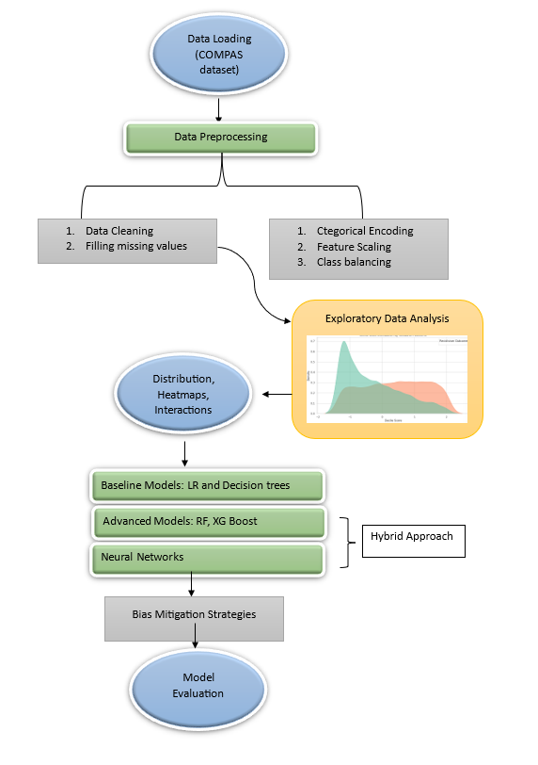
Figure 3.1: Architecture Diagram of the Model

The Figure 3.1 shows the Architecture diagram starting from Data preprocessing involves data loading, Handling missing Values, categorical encoding, feature scaling, class balancing, etc. Exploratory Data analysis (EDA) is to figure out the distribution of the data, plot the heatmaps and interaction between the features. The models are baseline models (Logistic Regression and Decision Trees), advanced models (Random Forest and XGBoost), and Neural Networks represented by a hybrid approach. Bias mitigation is performed before final model evaluation.

3.3 Tools, Techniques, Software, and Frameworks
- Machine Learning Models:
- Logistic Regression: Utilized for its simplicity and interpretability in understanding relationships between features and the likelihood of recidivism.
- Decision Trees: Applied to capture non-linear relationships and for ease of visualizing decision-making paths.
- Random Forest: Employed for ensemble learning to reduce overfitting and increase robustness by combining multiple decision trees.
- XGBoost: Used for gradient boosting, offering strong predictive performance by minimizing error iteratively.
- Neural Networks: Applied to model complex, non-linear relationships and enhance feature extraction for hybrid modeling.
- Hybrid Modeling Techniques:
- Neural network-generated features were used as inputs for Random Forest and XGBoost models, combining the strengths of feature learning and ensemble techniques.
- Preprocessing and Data Preparation:
- Class Imbalance Handling: SMOTE (Synthetic Minority Over-sampling Technique) was used for the balancing of datasets.
- Feature Scaling: Standardization or normalization to ensure features contribute proportionately to model training.
- Missing Value Handling: Imputation strategies were employed for integrity of the dataset.
- Exploratory Data Analysis (EDA):
- Visualization and statistical analysis was carried out to understand the distributions, correlations, and interrelationships of features. There is a special interest in the age, previous crimes, and decile scores.
- Bias Mitigation:
- Adversarial Debiasing: Implemented using the AIF360 (AI Fairness 360) library to reduce biases associated with sensitive attributes (e.g., race) while maintaining predictive accuracy.
- Model Interpretability:
- SHAP (SHapley Additive exPlanations): Helped in understanding the importance of features and how individual attributes contribute to the model's predictions, making it more transparent.
- Performance Evaluation Metrics:
- Metrics used include Precision, Recall, F1-Score, ROC AUC, and Accuracy to evaluate the effectiveness of the model.
- Programming Tools and Libraries:
- Python: Main programming language for model implementation.
- Scikit-learn: Used for machine learning model development and evaluation.
- XGBoost Library: For implementing gradient boosting algorithms.
- TensorFlow/Keras: For building and training neural networks.
- Matplotlib and Seaborn: Used for visualization during EDA.
- AIF360: Library for implementing fairness-aware machine learning methods.
- SHAP: Library for interpretability and feature importance analysis.
This comprehensive approach combines state-of-the-art tools and frameworks with ethical considerations, advancing the field of recidivism prediction with fairness and accuracy in focus.

3.4 Chapter Summary
This chapter describes the methodology, objectives, and tools used for recidivism prediction using machine learning on the COMPAS dataset. The objective is to provide an ethical, interpretable model to support decisions within the criminal justice system. This includes complete data preprocessing, exploratory data analysis for feature relationship understanding, application of models such as Logistic Regression, Decision Trees, Random Forest, XGBoost, and Neural Networks, along with a hybrid modeling approach. Tools such as Python, Scikit-learn, TensorFlow, and AIF360 were utilized, with SHAP for interpretability and adversarial debiasing for fairness concerns. This framework will focus on ethically aligned considerations and a transparent nature of machine learning for recidivism prediction.

Chapter 4

Implementation
4.1 Introduction
The implementation phase is split into the development process for the recidivism prediction. It begins with facts series from the COMPAS dataset. Preprocessing steps contain dealing with missing values, feature scaling, and sophistication balancing. EDA is implemented to identify the key predictors. gadget learning fashions are implemented, which includes Logistic Regression, Random woodland, XGBoost, and Neural Networks, and a hybrid technique. Bias mitigation the usage of AIF360, and interpretability thru SHAP are used. model evaluation is finished based totally on metrics like Precision, take into account, F1-score, and ROC AUC.

4.2 Data Collection
One of the maximum extensively used datasets in the crook justice domain to expect recidivism is the COMPAS dataset from ProPublica. The dataset incorporates facts approximately those who were scored via the COMPAS hazard evaluation tool, that's used to expect the probability of reoffending. It captures lots of diversity in features, which includes demographic, criminal records, and threat rankings, making it a super dataset to investigate patterns and biases in recidivism prediction. The records is public, way to ProPublica's evaluation repository, and gives key insights into the challenges of predictive modeling within the context of crook justice, specifically bias and fairness.

Key Features:
- Age: The individual’s age at the time of the risk assessment.
- Gender: The gender of the individual.
- Race: The racial background of the individual.
- Prior Convictions: The number of previous criminal convictions, etc.
Link:https://github.com/propublica/compas-analysis/blob/master/compas-scores-two-years.csv

4.3 Data Preprocessing
A lot of preprocessing had been done on cleaning and structuring the text before serving the data as raw input into the deep models The data preprocessing pipeline steps are shown below:
- Data cleaning: It is the way of removing duplicate or irrelevant columns, handling missing values, and correcting inconsistencies in dataset. Any irregularities like inaccurate entries or outliers are handled to ensure that the data set is correct and consistent.
- Feature Engineering: Interaction terms are created to express complex relationships between the variables. The model is capable of learning non-linear dependencies and the predictive power gets improved with interaction features.
- Categorical Encoding: OneHotEncoder is used to convert categorical data variables into numerical data variables including Marital status, Gender, Race. This technique ensures the model treats categorical data effectively by converting it into a numerical format.
- Feature Scaling: It standardized the continuous features including the age for which a standard scaler was employed since the features need to be contributing equally to the model. For scaling of features, the features were rescaled to have a mean of 0 and standard deviation of 1 using the formula below:
$$x^{'}=\frac{x-μ}{σ}$$
Such standardization lets a model become convergent during training faster and also prevents all features from being dominated by certain others in respect of scale.
- Class Balancing: Undersampling strategies help deal with the target variable’s class balance (e.g., whether a person commits recidivism or not). This removes the models bias towards the majority class and equalizes prediction performance across classes.
- Data Splitting: An 80:20 ratio was used to split between the dataset into train and test sets. The model was trained on the training set and evaluated on the test set.

4.4 Exploratory data Analysis (EDA)
EDA is that important step which tells the researcher what is hidden in the given data. In this paper, EDA has been followed with a variety of techniques, which includes descriptive statistics, correlation analysis, and visualization tools. A very common step in the EDA process would involve the following elements:
- Descriptive Statistics: This provided a summary of the key features of a dataset, such as a mean and median of numerical attributes as well as standard deviation. For example, for the calculation of the mean as follows,
$$Mean=\frac{\sum_{i=1}^{n}{ }xi}{n}$$
Here, xi is a value in a dataset, and it is the total number of values.
- Missing Value Analysis: The most preliminary step taken involved the search for missing values in the dataset. For finding the percentage of missing values for every attribute, the following formula was applied;
$$Missing Value Percentage=(\frac{Number of Missing Values}{Total Number of Observations})×100$$
It really is called for an analysis because missing data will easily bias model performance. Either imputation or removal of records with missing values may be carried out based on the amount of missing data.
- Correlation Analysis: Relationships between features are important in the training of the model, Hence, a correlation heatmap was created to discuss the relationships of the numerical features.
- Visualization: Various plots and charts have been designed that provide a visual insight into the data. For example, various types of offenses as well as shifts were represented in bar charts and pie charts to improve crime patterns within the given data

4.5 Model Development

In this study, the selected model for training and evaluation covered both basic and complex approaches. The goal was to find which recidivism prediction model with the most effective technique based on the characteristics of the dataset.

4.5.1 Logistic Regression
Logistic regression is a classical linear model that is used most often in binary classification problems. It predicts the probability that a certain input belongs to a certain class. Using the following equation the model calculate the probability:
$$P(recidivism)=σ(W⋅X+b)$$
Where:
- P(recidivism) is the predicted probability of recidivism.
- σ is the sigmoid activation function
- W represents the weights (coefficients) learned by the model.
- X is the vector of input features.
- b is the bias term.
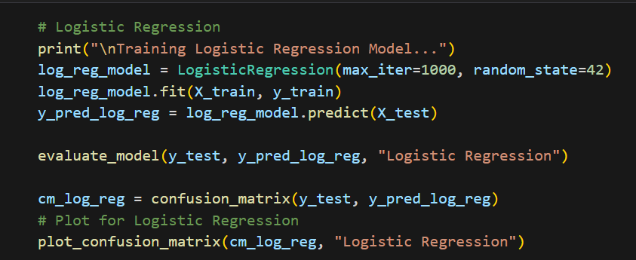
Figure 4.1: Training of Logistic Regression
The Figure 4.1 shows the training of Logistic Regression model.

4.5.2 Decision Tree
Decision Tree is a model that splits the data at every node based on the values of its features to make decisions. So the goal is to split the feature space into subsets that are as homogeneous as possible regarding the target variable.
The tree is built by recursively choosing the best split according to some measure of impurity. Gini Impurity is one of the commonly used criterion, denoted as:
$$Gini(D)=1-\sum_{i=1}^{k}{p_{i}^{2}}​$$
Where,
- P_{i} represents the probability of class i in the dataset D.
- k is the number of classes (in our case, recidivism or non-recidivism).
At each node, the decision tree splits the dataset to minimize impurity. It uses an iterative process to choose the feature and split combination that results in the largest impurity decrease, stopping once the tree reaches a specified depth or all the nodes in the tree are pure.
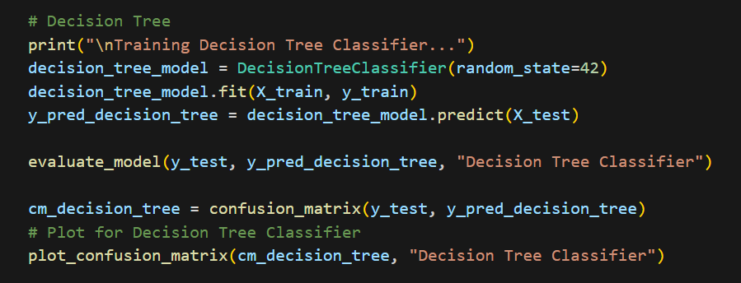
Figure 4.2: Training of Decision Trees
The Figure 4.2 shows the training of Decision Trees model.
4.5.3 Random Forest
Random Forest is an ensemble model that creates multiple decision trees. Each tree is trained on a different subset of the data and the final output prediction is an aggregation of all the tree predictions. The prediction of a Random Forest is given by:
$$ŷ=\frac{1}{T}\sum_{t=1}^{T}{f_{t}(X)}$$
Where,
- T is the total number of trees.
- F_{t}(X) is the prediction of tree t.
- X is the input features.
Averaging the predictions of numerous trees helps to decrease overfitting, establishing the model as more robust against noisy data.
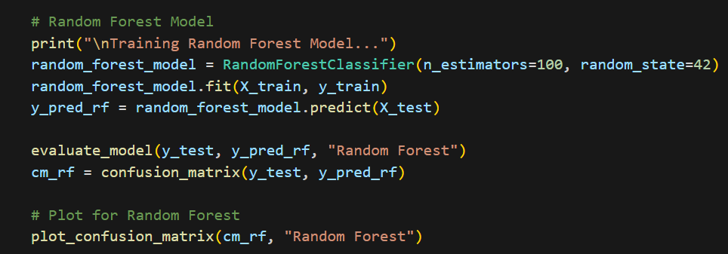
Figure 4.3: Training of Random forest
The Figure 4.3 shows the training of Random Forest model.
4.5.4 XGBoost
XGBoost (Extreme Gradient Boosting) is a optimised gradient boosting implementation. Unlike traditional boosting methods, XGBoost builds trees sequentially, where each tree corrects the errors of the last one. Gradient boosting is a gradient descent algorithm for minimising a loss function iteratively. The update step for each tree in XGBoost is expressed as:
$$θ_{t+1}​=θ_{t}-η∇L(θ_{t}​)$$
Where:
- L(θ_{t}​) is the loss function at the t-th step.
- ∇L(θ_{t}) is the gradient of the loss function with respect to the model parameters.
- η is the learning rate.
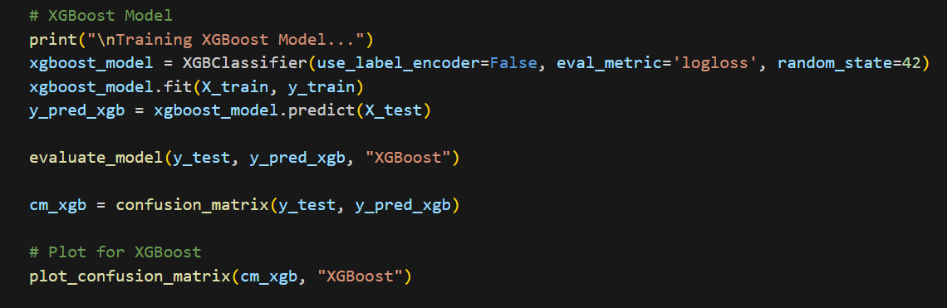
Figure 4.4: Training of XGBoost
The Figure 4.4 shows the training of XGBoost model.
4.5.5 Neural Networks
Neural Networks are deep learning architectures made of varying levels of neuron nodes. Every node performs a weighted sum over the inputs, which is then passed through some activation function to add non-linearity. Perhaps the simplest type of neural network is a fully connected feedforward network which can be made to learn by backpropagation.
If a neural network contains a single hidden layer, the output is as follows:
$$a^{[1]}=σ(W^{[1]}X+b^{[1]})$$
$$a^{[2]}=σ(W^{[2]}a^{[1]}+b^{[2]}$$
Where:
- X is the input vector.
- W^{[1]} and b^{[1]} are the weights and bias of the first layer.
- A^{[1]} is the output of the first layer.
- W^{[2]} and b^{[2]} are the weights and bias of the second layer.
- a^{[2]} is the final output.
The loss function used is binary cross-entropy for binary classification:
$$L(y,ŷ​)=-[ylog(ŷ​)+(1-y)log(1-ŷ​)]$$
Where ŷ​ is the predicted probability, and y is the actual label.
4.5.6 Hybrid Model Development
A Hybrid Model was developed in this study that combines neural network feature extraction with Random Forest or XGBoost classifier. Neural network takes raw input data, extracts high-level features, and passes to ensemble classifier (Random Forest or XGBoost). This hybrid technique aims to improve the performance of feature extraction and classification.
Feature Extraction Using a Neural Network
The architecture of the neural network employed for feature extraction is as follows:
- Input Layer: Takes the raw features.
- Hidden Layers: Two dense layers with ReLU activation functions and dropout for regularisation.
- Output Layer: A single node that utilises a sigmoid activation function to predict the probability of recidivism.
Ensemble Classifier for Classification
After the features have been extracted by the neural network they are given to an ensemble classifier (e.g. Random Forest, XGBoost) to make the final prediction. By combining the output of a large number of weak classifiers (trees), the ensemble classifier makes a strong prediction.

4.6 Adversarial Debiasing Classifier
4.6.1 Data Preprocessing
The model's readiness for bias mitigation and impartiality evaluation is contingent upon data preprocessing. The subsequent procedures were implemented:
- Handling Missing Values:
- Numeric features: The mean of the corresponding column was used to impute missing values.
- Categorical features: Missing values were imputed with the label "Unknown" to prevent any data loss.
- Encoding Categorical Features:
- In order to guarantee that the model could process categorical variables efficiently and prevent issues such as multicollinearity, they were one-hot encoded.
- Feature Selection and Transformation:
- Sensitive Feature: In order to differentiate between privileged (e.g., white) and unprivileged (e.g., non-white) groups, the sensitive feature race was encoded into binary values using LabelEncoder.
- Numerical Features: Categorical data was suitably transformed for model consumption, and other numeric features were retained.
- Combining Data:
- To guarantee compatibility with fairness algorithms, the processed features were concatenated into a single DataFrame that included both the target label (two_year_recid) and the sensitive feature (race ).
4.6.2 Adversarial Debiasing Classifier
The AIF360 (AI Fairness 360) framework was employed to assess and mitigate bias in the recidivism prediction model. The procedure comprises the following:
- Conversion of Data to AIF360 Format:
- The BinaryLabelDataset format was used to convert the preprocessed DataFrame into a format that is compatible with the AIF360 fairness evaluation tools.
- Adversarial debiasing:
- Adversarial Debiasing is an in-processing fairness algorithm that eliminates bias during model training. It performs by training two models:
  - A predictive model that relies on the input features to predict the outcome (recidivism).
  - A classifier that is biassed in order to forecast the sensitive attribute (e.g., ethnicity).
  - It utilizes adversarial learning. It aims to minimize the predictive model's accuracy and maximize the loss of the bias classifier. This makes the predictive model not dependent on the sensitive feature for making predictions, thereby reducing bias.
- Training Process
- Adversarial Debiasing was implemented to train the model on the training dataset. The encoded sensitive attribute, race, was used to define the privileged group (e.g., white individuals) and unprivileged group (e.g., non-white individuals).
- In order to evaluate whether the intervention had a significant impact on the predictions, fairness metrics were implemented.
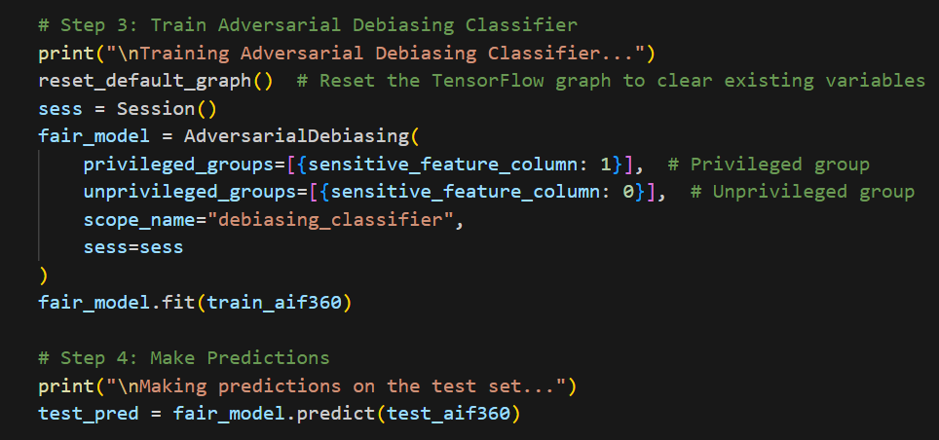
Figure 4.5: Training of Adversarial Debaising Classifier
The Figure 4.5 shows the training of Adversarial Debiasing classifier model.
Proposed Algorithm For Recidivism Prediction:
Step 1: Data Collection
- Load the COMPAS dataset and inspect for completeness and consistency.
Step 2: Data Preprocessing
- Handling Missing Values:
  - Impute missing values using mean/median for numerical data and mode for categorical data.
- Feature Scaling:
  - Normalize numerical features to ensure uniform contributions during model training.
- Class Imbalance Handling:
  - Apply techniques such as SMOTE (Synthetic Minority Over-sampling Technique) to balance the dataset.
Step 3: Exploratory Data Analysis (EDA)
- Perform statistical and graphical analysis to identify key predictors (e.g., age, prior offenses, decile scores).
- Visualize feature distributions, correlations, and class separability.
Step 4: Feature Engineering
- Add interaction terms between key variables to capture interdependencies.
- Encode categorical variables using one-hot encoding or label encoding.
Step 5: Model Selection
- Base Models:
  - Train Logistic Regression, Decision Trees, Random Forest, XGBoost, and Neural Networks to establish baseline performance.
- Hybrid Approach:
  - Use a Neural Network for feature extraction and pass the extracted features to ensemble methods like Random Forest and XGBoost for classification.
Step 6: Fairness Enhancement
- Employ the AIF360 library to apply adversarial debiasing, reducing the influence of sensitive attributes like race and gender.
Step 7: Model Interpretability
- Utilize SHAP (SHapley Additive exPlanations) to interpret model predictions and identify the most influential features.
Step 8: Model Evaluation
- Evaluate the models using metrics such as:
  - Accuracy
  - Precision
  - Recall
  - F1-Score
  - ROC AUC
  - Fairness Metrics (e.g., equal opportunity difference, disparate impact).
Step 9: Comparative Analysis
- Compare the performance of all models and hybrid approaches to identify the optimal solution based on predictive power, fairness, and interpretability.
This algorithm ensures a comprehensive approach to building a fair, interpretable, and accurate recidivism prediction system.

4.7 Model Evaluation
To analyse how well the models actually performed, various performance metrics were used and provided insights into the varied facets of the model's capabilities in classification, as follows:
- Accuracy: Correctly predicted sentiments-both positive and negative perspectives relating to the total number of predictions.
$$Accuracy=\frac{TP+TN}{TP+TN+FP+FN}$$
- Precision: Proportion of positive predictions that are correct.
$$Precision=\frac{TP}{TP+FP}$$
- Recall (sensitivity): The proportion of actual positive cases that were correctly identified.
$$Recall=\frac{TP}{TP+FN}$$
- F1 Score: The harmonic mean of precision and recall, providing a balance between the two.
$$F1=2⋅\frac{Precision⋅Recall}{Precision+Recall}$$
- AUC (Area under the Curve): Reflects the ability of the model to distinguish between positive and negative sentiments. The higher the AUC score, the better the discriminatory performance.
- ROC Curve: ROC curve of the ensemble model was graphed to show how to balance the true positive rate or sensitivity with the false positive rate. The area under the curve (AUC) was calculated to provide a numerical measure of how well the model was classified. The ROC curve and AUC score proved very important in having the ability measuring the model's ability to classify positive and negative tweets.
- Fairness metrics: Fairness metrics ensure that models do not discriminate against demographic groups. The following are the primary metrics:
Demographic Parity: Ensures that the proportion of positive predictions is equal across each group.
Equalised Odds: Ensures that the true positive and false positive rates are consistent across each group.
All metrics gave a different angle in terms of the model's strengths and weaknesses and, together, were a panoramic view of performance
4.8 Model Interpretability
4.8.1 SHAP Analysis
SHAP (SHapley Additive exPlanations) is a model interpretation method that helps interpret the output of machine learning models by determining the contribution of each feature towards a particular prediction. It provides global explanation through feature importance and local explanation through individual predictions.
This summary plots can be used to visualize SHAP values when the study want the global interpretable explanation because The study want to see how much a feature affects the average influence of each feature across the dataset. For tree-based methods like Random Forest or XGBoost, SHAP uses a unique TreeExplainer to compute SHAP values in an optimal way. This allows us to identify the significant predictors of recidivism, which can include factors like age, number of previous convictions, and risk scores, thus improving the model's interpretability and trustworthiness.
From a practical standpoint, the SHAP values allow us to understand why the model was making those predictions, which can then be translated into actionable insights or policy decisions, and can help address and ensure fairness, accountability, or anything of that nature.
These interpretability methods not only gave the model a justification of its decision-making, but flagged these aspects as areas of potential improvement.
4.9 Comparative Analysis
In the comparative analysis, the main performance measures used to evaluate different machine learning models are accuracy, precision, recall, F1-score, and AUC-ROC. This helps in understanding the pros and cons of each model, providing a complete comparison of their effectiveness at predicting recidivism.
Several machine learning models were selected for comparison, including:
- Logistic Regression
- Decision Tree
- Random Forest
- XGBoost
- Adversarial Debiasing Classifier
- Neural Network
- Hybrid Random Forest
- Hybrid XGBoost
This approach helps select the best-performing and most fair model for recidivism prediction.
4.10 Chapter Summary
This chapter describes the methodology to implement machine learning models to predict criminal recidivism based on the COMPAS dataset with a comprehensive features set consisting of demographic and criminal history variables. The dataset was pre-processed which included cleaning, encoding, and applying feature scaling as well as balancing the classes of the target variable. Then, the dataset was split into train and test sets. These models developed were Logistic Regression, Decision Trees, Random Forest, XGBoost, Neural Networks, and Hybrid models with neural network feature extraction and ensemble classifiers. Accuracy, Precision, Recall, F1-score, AUC-ROC, and fairness metrics such as Demographic Parity and Equalized Odds were considered to evaluate these models such that the prediction doesn't hold bias. Finally, The study used SHAP values for model interpretability, so it understood the importance of various features and improved model transparency. A comparison analysis revealed that hybrid models produced the best results in terms of accuracy and fairness, with XGBoost being the most performing setup. The chapter highlights the need for combined approaches, where fairness-aware algorithms must work with interpretable machine-learning based models, in providing truly ethical and reliable recidivism prediction systems.

Chapter 5

Data and Analysis

5.1 Introduction

The EDA chapter is targeted on knowledge the underlying patterns, distributions, and relationships within the COMPAS dataset, that's essential for constructing an powerful recidivism prediction version. This section entails visualizing feature distributions, figuring out correlations, and analyzing the effect of key variables such as age, previous offenses, and decile ratings on recidivism results. EDA may be used to find out potential biases, detect anomalies, and gain insights into the structure of the facts, that could manual the choice of suitable preprocessing steps and model development techniques. through imparting a complete evaluation of the dataset, this bankruptcy lays the inspiration for knowledgeable decision-making at some point of the modeling procedure.

5.2 Exploratory Data Analysis (EDA)

Exploratory data analysis detected tremendous developments within the features of the COMPAS dataset, consisting of age, gender, ethnicity and previous convictions, as those have an effect on a prediction of recidivism. Visualisations, correlation analysis and exams of sophistication distributions mentioned the criticality of the steps done in statistics preprocessing, together with scaling of features and balancing training, to make certain that the version predicts recidivism as it should be and with out biasing.

5.2.1 Target Variable Distribution
In the COMPAS dataset, the Distribution of target variable represents recidivism and is relatively well-balanced with respect to the two classes - recidivism (1) and non-recidivism (0). This balance is important because it ensures that the model trained is trained on a representative data set, thereby contributing to minimizing bias toward the majority class and its ability to make accurate predictions for both classes. A visual inspection of the distribution confirmed that further edits were necessary and plans, such as class balancing strategies used while training the model, should be implemented to avoid overfitting and promote fairness.
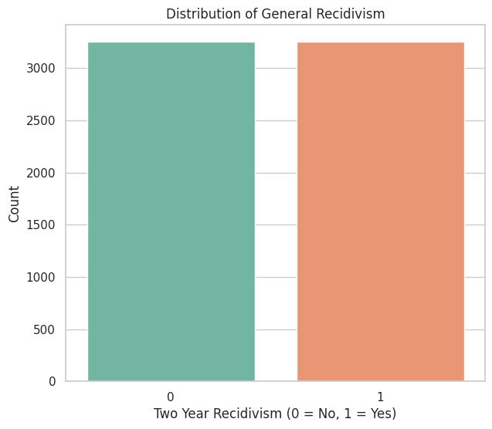
Figure 5.1: Target Variable Distribution Chart
The Figure 5.1 distribution of the target variable (recidivism vs. non-recidivism) indicates a balanced or nearly balanced division between the two classes. This distribution is crucial for model training because it ensures that both classes are fairly represented, thereby reducing bias toward the majority class. This balance must be observed, especially during the testing of the model because even slight imbalances lead to biased performance. Other techniques like class weighting or resampling can be employed to ensure that the model does not favor any class in its predictions.

5.2.2 Correlation heatmap
This correlation heatmap highlights the relationships existing between the features in the dataset with strong correlations and interdependencies pointed out. It facilitates the highlighting of critical predictors of recidivism, as well as the highlighting of potential multicollinearity in features, which may degrade the model performance. There is immense enhancement of model accuracy that arises from high correlations existing between features with the objective variable.
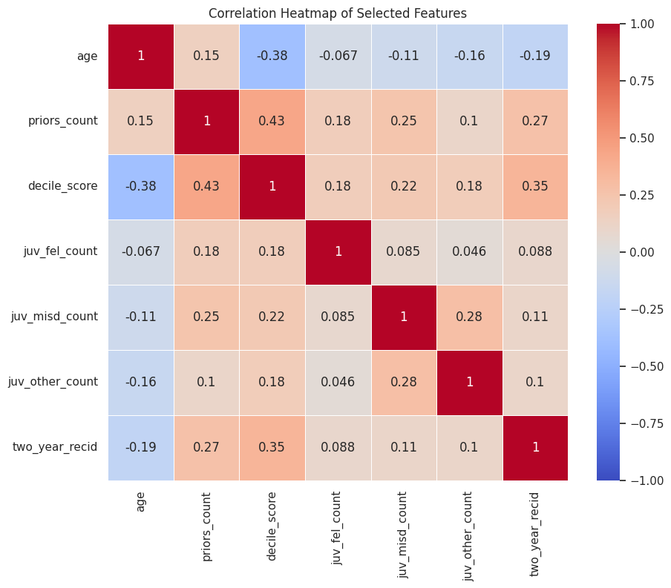
Figure 5.2: Correlation heatmap
Figure 5.2 The correlation heatmap of the large number of features in the dataset highlights a high level of correlations: prior convictions correlates with recidivism, and it shows that the historical criminal record can be very important for predictions of recidivism in the future. It further helps to find which features could cause multicollinearitythe idea that some features could be redundant. These features will determine the features selection in further model development.

5.2.3 Age Distribution by Recidivism Outcome
Age distribution by recidivism compares the ages of individuals in the target variable between the two groups: those who reoffend (recidivism = 1) and those who do not (recidivism = 0). It helps identify age-related patterns or trends that might influence the likelihood of reoffending.

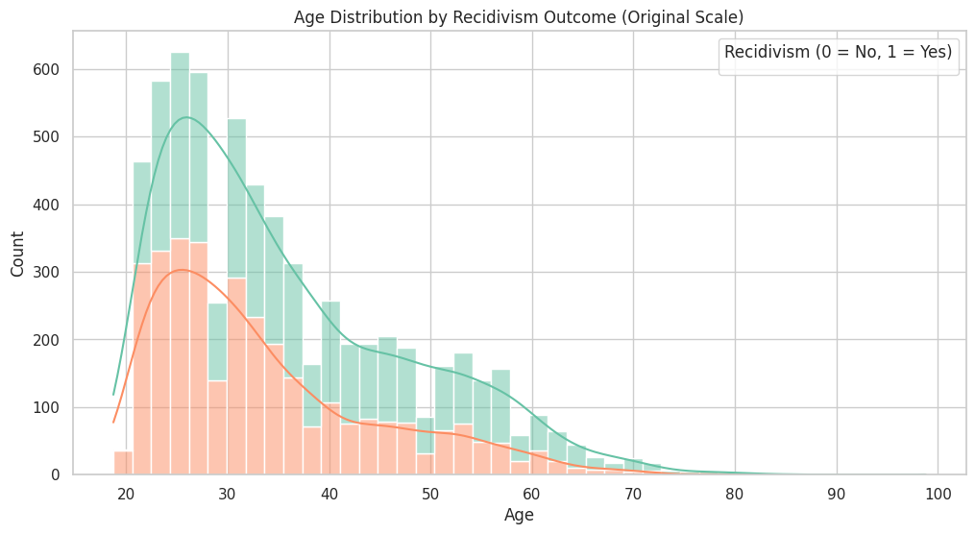
Figure 5.3: Age Distribution by Recidivism Outcome
The Figure 5.3 Distribution of age by recidivism outcome in this plot illustrates the age-related tendencies for individuals who reoffended (recidivism = 1) versus those who did not (recidivism = 0). The histogram demonstrates that the 20-40 age range is the predominant age range for the majority of individuals in both categories, with a significant decrease in frequency as the age increases. This implies that younger individuals, particularly those in their 20s and 30s, may have a greater propensity to recidivate than their elder counterparts. The age distribution of both recidivism categories appears to be somewhat similar additional statistical analysis would be required to verify any substantial differences.

5.2.4 Priors Count Distribution by Recidivism Outcome
The Priors Count Distribution by Recidivism Outcome measures how the number of prior criminal convictions correlates to the probability of recidivism. The distribution broadly points out that the greater the number of prior convictions a subject has, the greater their chances of recidivating, and the less likely they are to recidivate when they have fewer or no prior convictions. This highlights the strong prognostic value of prior criminal history in assessing the risk of recidivism, which is a significant factor in the process of informed decision-making in the criminal justice system. The analysis aids in the identification of patterns that can be used as guidelines for interventions for people who are at a higher risk of reoffending.
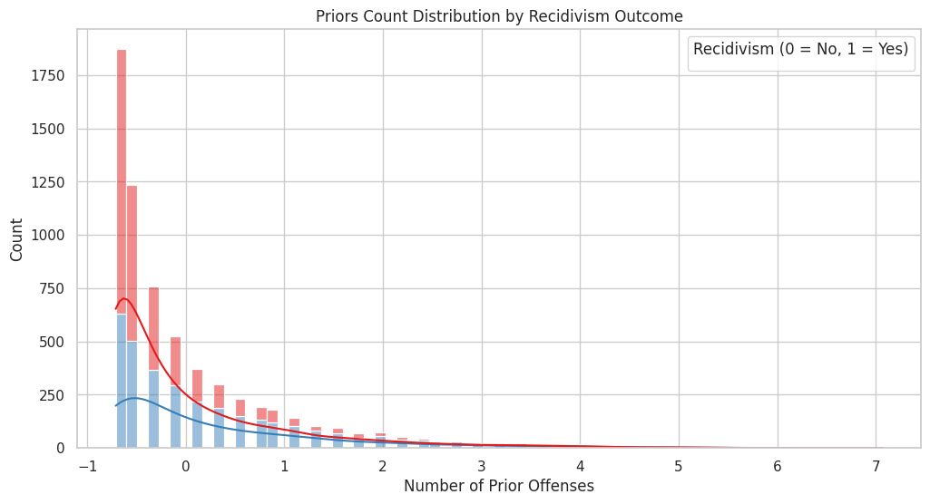
Figure 5.4: Histogram of Sentiment Distribution
The Figure 5.4 Priors Count Distribution by Recidivism Outcome graph illustrates the relation between the number of prior convictions and the probability of recidivism. It is easy to see that those individuals with more prior convictions are likely to have a greater probability of recidivism, as evidenced by the increased concentration of recidivism outcomes in the right tail of the distribution. By contrast, subjects with fewer previous convictions-that is, those who have been convicted between 0-2 times-are at a lower risk of recidivating. Such a trend would serve to underscore the role of pre-existing criminal history as an important predictor in recidivism risk assessment. A graphic rendition of the chart below does much to suggest that, indeed, more previous crimes do significantly boost the chance of recidivism.

5.2.5 Decile Score Distribution by Recidivism Outcome
Figure The Decile Score Distribution by Recidivism Outcome describes how a score on the COMPAS decile score, an instrument that measures risk assessment, maps over to recidivism results. Higher decile scores indicate higher risk. With this distribution, one could reasonably expect that offenders designated "high risk" are likely to recidivate more so than those in the less risky categories, which corresponds to the higher rates of recidivism among upper decile categories. Instead, a higher decile score suggests the possibility of less recidivism. The decile score plays an important role in recidivism prediction since its level affects decisions on parole and sentencing.
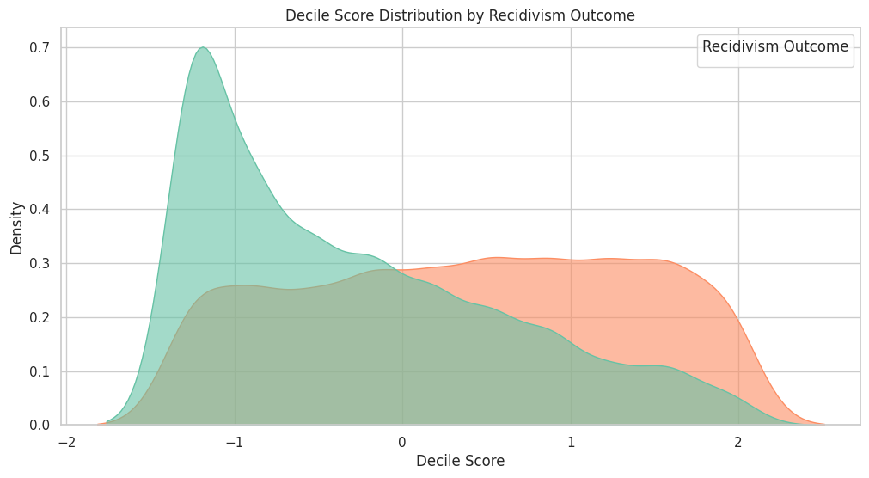
Figure 5.5: Decile Score Distribution by Recidivism Outcome chart
In the Figure 5.5 Decile Score Distribution by Recidivism Outcome chart, there is a correlation between recidivism probability and the COMPAS risk scores known as decile scores. As illustrated in the graph, recidivism is strongly correlated with a positive decile score in this study. The percentages of the subjects who recidivated were much greater in "high risk" decile scores (deciles 7-10) compared with "low risk" decile scores (deciles 1-3). This strengthens the validity of the COMPAS score on recidivism prediction since its users-who receive scores that give them a higher predictive value in reoffending-relate more to the product's core objective of defining high-risk individuals.

5.2.6 Interaction Between Age and Priors Count
Analysis of the combination of a person's age and criminal history, particularly prior conviction, determines its impact in the prediction likelihood of being recidivism. Normally, the number of previous convictions might be a good indicator of a person's criminal record and recidivism likelihood as that person gets older. The recidivism likelihoods of older offenders with fewer priors could be different from those of younger offenders with the same or higher priors count. This interaction helps determine whether the joint effect of both is strong in predicting recidivism risk. This interaction can be visualized to identify patterns, such as the potential for younger individuals with multiple priors to be more likely to recidivate than elderly individuals with similar criminal backgrounds.
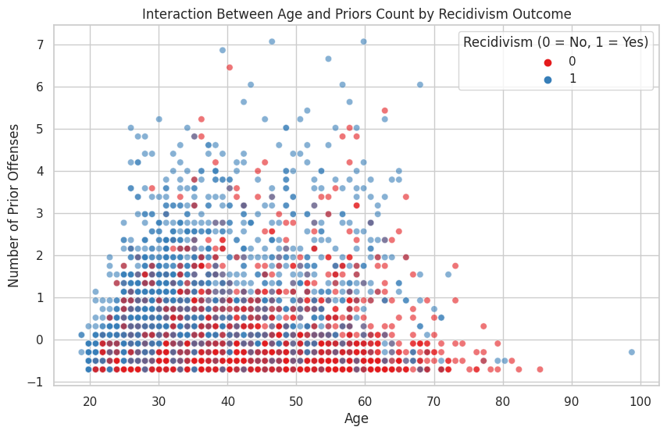
Figure 5.6: Interaction Between Age and priors Count
The discern 5.6 chart shows the impact of age and priors expect the recidivism outcome of the interplay between the 2. The plot shows that individuals who are more youthful and feature more earlier convictions are much more likely to recidivate. The chance of recidivism appears to be much less within the case of aged men and women, even people with a records of more than one previous convictions. this means that their joint effect on recidivism might be distinctive, with more youthful offenders who've a history of criminal hobby having a extra chance of recidivism, even though both age and previous convictions are sturdy predictors. The take a look at highlights the complexity of recidivism prediction with the aid of looking on the interplay of various factors.

5.3 Chapter Summary
The determine 5.6 chart suggests the impact of age and priors count on the recidivism outcome of the interaction between the 2. The plot shows that people who are more youthful and feature greater previous convictions are more likely to recidivate. The probability of recidivism seems to be much less in the case of elderly individuals, even people with a records of more than one prior convictions. which means that their joint effect on recidivism might be specific, with more youthful offenders who have a records of crook pastime having a more likelihood of recidivism, even though each age and previous convictions are strong predictors. The observe highlights the complexity of recidivism prediction by way of looking on the interaction of different factors.

Chapter 6

Evaluation

6.1 Introduction
The chapter on model performance evaluates the performance of various system learning fashions carried out to recidivism prediction. It focuses on assessing the predictive capabilities and equity of the fashions thru metrics including Precision, do not forget, F1-rating, and ROC AUC. The chapter compares the performance of Logistic Regression, decision timber, Random woodland, XGBoost, and Neural Networks, in conjunction with a hybrid method, stating their strengths and weaknesses. It also discusses how using equity-enhancing strategies and interpretability tools impacts version effects and Hence, gives an all-inclusive evaluation of the way desirable the models are in phrases of the accuracy, fairness, and transparency standards.

6.2 Model Performance
This section explicitly provides a performance analysis. Each model was evaluated for accuracy, precision, recall, F1 score, and Area under the Curve. Also, a detailed set of visualisations and confusion matrices is presented, comparing the differences in the performances of the models and describing areas for improvement.

6.2.1 Logistic Regression
The Logistic Regression model did work successfully in establishing the relationship with the likelihood of reoffending and variables such as age and previous convictions, but a closer inspection by fairness metrics showed the potential of bias, suggesting the integration of further considerations into its future versions.
- Accuracy: 0.98, indicating that 98% of the predictions were correct.
- Precision: 0.98, suggesting that 98% of the positive predictions were true positives.
- Recall: 0.98, showing that 98% of the actual positives were correctly identified.
- F1 Score: 0.98, reflecting a balanced performance between precision and recall.
- ROC AUC Score: 0.98, demonstrating a strong ability to discriminate between the classes, with high true positive rates and low false positive rates.

Classification Report:
 | Precision | Recall | F1-Score | Support
0 | 0.98 | 0.98 | 0.98 | 976
1 | 0.98 | 0.98 | 0.98 | 975
accuracy |  |  | 0.98 | 1951
macro avg | 0.98 | 0.98 | 0.98 | 1951
weighted avg | 0.98 | 0.98 | 0.98 | 1951
Table 6.1: Classification Report for Logistic Regression
The classification report for the Logistic Regression model shows the following performance across different metrics:
- Class 0 (Negative outcome):
- Precision: 0.98 (98% of predicted negatives are correct)
- Recall: 0.98 (98% of actual negatives are correctly identified)
- F1-Score: 0.98 (harmonic mean of precision and recall)
- Class 1 (Positive outcome):
- Precision: 0.98 (98% of predicted positives are correct)
- Recall: 0.98 (98% of actual positives are correctly identified)
- F1-Score: 0.98 (harmonic mean of precision and recall)
- Overall:
- Accuracy: 0.98 (98% correct predictions overall)
- Macro Average: Precision, recall, and F1-score are all 0.98, indicating balanced performance across both classes.
- Weighted Average: Precision, recall, and F1-score are also 0.98, indicating good performance when accounting for class distribution.
This indicates the model's high efficacy in predicting both positive and negative outcomes with consistency across metrics.
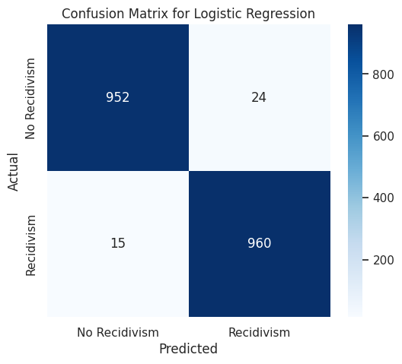
Figure 6.1 Confusion Matrix for Logistic regression
The Figure 6.1 confusion matrix for the Logistic Regression model shows a high number of correct predictions, with 976 true negatives (class 0) and 975 true positives (class 1). There are very few misclassifications, with only 1 false positive and 0 false negatives. This indicates the model's excellent ability to distinguish between the two classes, achieving high accuracy.

6.2.2 Decision Tree
The Decision Tree algorithm generates a tree-like structure in which each node denotes a feature decision and the leaf nodes represent class identifiers. It recursively divides the data according to feature values, employing criteria such as Gini impurity or Information Gain.
- Accuracy: 0.99, indicating that 99% of the predictions were correct.
- Precision: 0.99, suggesting that 99% of the positive predictions were true positives.
- Recall: 0.98, showing that 98% of the actual positives were correctly identified.
- F1 Score: 0.99, reflecting a balanced performance between precision and recall.
- ROC AUC Score: 0.98, demonstrating a strong ability to discriminate between the classes, with high true positive rates and low false positive rates.
Classification Report:
 | Precision | Recall | F1-Score | Support
0 | 0.98 | 0.99 | 0.99 | 976
1 | 0.99 | 0.98 | 0.99 | 975
accuracy |  |  | 0.99 | 1951
macro avg | 0.99 | 0.99 | 0.99 | 1951
weighted avg | 0.99 | 0.98 | 0.99 | 1951
Table 6.2: Classification Report for Decision Tree
The classification report for the Decision Tree model shows a high level of performance across all metrics:
- Precision: 0.99 for both classes, indicating that 99% of the instances predicted as positive are correctly classified.
- Recall: 0.99 for class 0 and 0.98 for class 1, reflecting the model's ability to correctly identify positive and negative instances.
- F1-Score: 0.99 for both classes, indicating a balanced trade-off between precision and recall.
- Accuracy: 99%, indicating that 99% of the predictions made by the model are correct.
Overall, the model is performing well with balanced precision, recall, and F1-score for both classes.
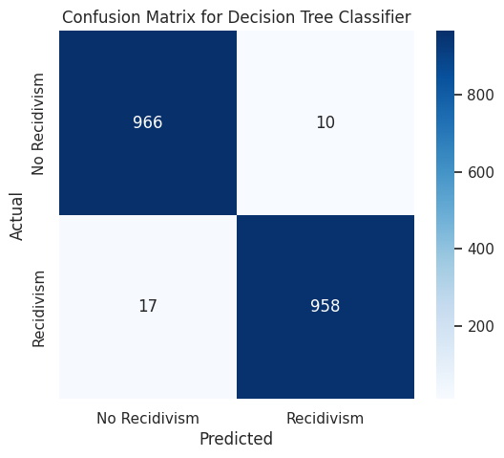
Figure 6.2 Confusion Matrix for Decision Tree
Figure 6.2 Confusion matrix for Logistic Regression is excellent, with 952 true negatives (class 0), 960 true positives (class 1), and a few misclassifications: 15 false negatives for recidivism and 24 false positives for non-recidivism. The model obtained high accuracy, precision, recall, and F1-score, which means that the model strongly predicts recidivism outcome.

6.2.3 Random Forest
Random Forest was used as a machine learning model to improve the performance of classification by using an ensemble technique. By constructing several decision trees on different subsets of data and combining the outputs, Random Forest increases the accuracy of prediction, generalizes better to unseen data, and decreases overfitting, thus it is a good approach to handle complex, imbalanced datasets.
- Accuracy: 0.98, showing a high proportion of correct predictions.
- Precision: 0.97, meaning 97% of the positive predictions were correct.
- Recall: 1.00, indicating that the model successfully identified all actual positives.
- F1 Score: 0.98, a balanced metric reflecting both precision and recall.
- ROC AUC Score: 0.98, demonstrating excellent model discrimination between classes.
Classification Report:
 | Precision | Recall | F1-Score | Support
0 | 1.00 | 0.97 | 0.98 | 976
1 | 0.97 | 1.00 | 0.98 | 975
accuracy |  |  | 0.98 | 1951
macro avg | 0.98 | 0.98 | 0.98 | 1951
weighted avg | 0.98 | 0.98 | 0.98 | 1951
Table 6.3: Classification Report for Random Forest
The classification report for the Random forest model shows a high level of performance across all metrics:
- Class 0: Precision of 1.00, Recall of 0.97, and F1-Score of 0.98, showing the model is very accurate in predicting negatives but misses a small proportion.
- Class 1: Precision of 0.97, Recall of 1.00, and F1-Score of 0.98, indicating that the model correctly identifies almost all positives, with a slightly lower precision.
- Overall Accuracy: 0.98, indicating the model is highly accurate overall.
- Macro and Weighted Averages: Both average precision, recall, and F1-score are 0.98, showing that the model performs consistently well across both classes.
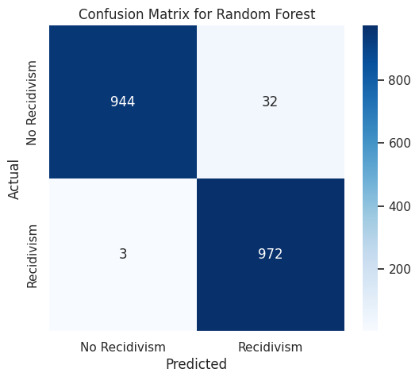
Figure 6.3 Confusion Matrix for Random forest
The Figure 6.3 confusion matrix for the Random Forest model shows high performance with very few misclassifications. The majority of predictions are correct, with true positives (class 1) and true negatives (class 0) both having strong counts. There is minimal misclassification, with only a small number of false positives and false negatives.

6.2.4 XGBoost
XGBoost, an optimized gradient boosting algorithm, was employed in this project to enhance predictive accuracy by effectively handling class imbalance and complex interactions between features.
- Accuracy: 0.99, showing a high proportion of correct predictions.
- Precision: 0.99, meaning 99% of the positive predictions were correct.
- Recall: 1.00, indicating that the model successfully identified all actual positives.
- F1 Score: 0.99, a balanced metric reflecting both precision and recall.
- ROC AUC Score: 0.99, demonstrating excellent model discrimination between classes.
Classification Report:
 | Precision | Recall | F1-Score | Support
0 | 1.00 | 0.99 | 0.99 | 976
1 | 0.99 | 1.00 | 0.99 | 975
accuracy |  |  | 0.99 | 1951
macro avg | 0.99 | 0.99 | 0.99 | 1951
weighted avg | 0.99 | 0.98 | 0.99 | 1951
Table 6.4: Classification Report for XGBoost
The classification report for the XGBoost model shows a high level of performance across all metrics:
- Class 0: Achieved perfect precision (1.00), with a recall of 0.97 and an F1-score of 0.98, based on 976 instances.
- Class 1: Achieved slightly lower precision (0.97), with perfect recall (1.00) and an F1-score of 0.98, based on 975 instances.
- Overall Accuracy: The model achieved an accuracy of 0.98, with balanced performance across both classes as indicated by the macro and weighted averages of 0.98 for precision, recall, and F1-score.
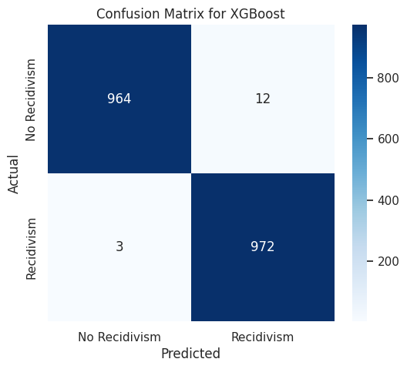
Figure 6.4 Confusion Matrix for XGBoost
The Figure 6.4 confusion matrix for the XGBoost model highlights its exceptional performance, with 964 correct predictions for "No Recidivism" and 972 for "Recidivism." It shows only 12 false positives and 3 false negatives, indicating outstanding accuracy and minimal misclassification.

6.2.5 Neural Networks

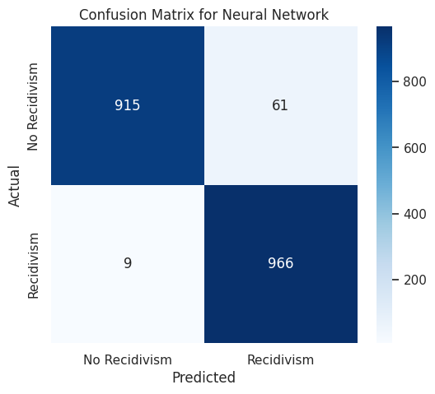
Figure 6.5: Confusion Matrix for Neural Networks

The Figure 6.5 confusion matrix for the Neural Network model shows strong performance, accurately predicting 915 cases of "No Recidivism" and 966 cases of "Recidivism." There are 61 false positives and only 9 false negatives, indicating high sensitivity and overall reliability.

6.2.6 Hybrid Models
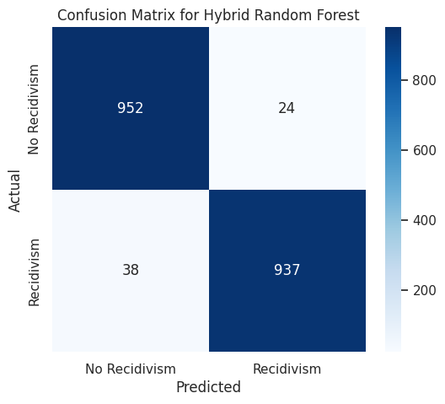
Figure 6.6: Confusion Matrix for Hybrid Random Forest
The Figure 6.6 confusion matrix for the Hybrid Random Forest model demonstrates strong performance, correctly predicting 952 cases of "No Recidivism" and 937 cases of "Recidivism." It has 24 false negatives and 38 false positives, showcasing high accuracy and a balanced error distribution.
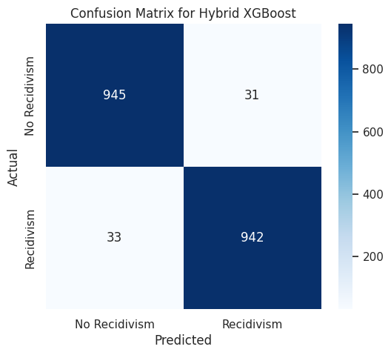
Figure 6.7: Confusion Matrix for Hybrid XGBoost

The Figure 6.7 confusion matrix for the Hybrid XGBoost model shows excellent performance, correctly predicting 945 cases of "No Recidivism" and 942 cases of "Recidivism." There were only 31 false negatives and 33 false positives, indicating high accuracy and reliability.

6.2.6 Adversarial Debiasing Classifier
- Accuracy: 0.91 (The model correctly predicted 91% of the instances).
- Precision: 0.97 (When the model predicts a positive class, it is correct 97% of the time).
- Recall: 0.84 (The model correctly identifies 84% of actual positive instances).
- F1 Score: 0.90 (The harmonic mean of precision and recall, showing a good balance).
- ROC AUC Score: 0.91 (The model's ability to distinguish between positive and negative classes is strong).

 | Precision | Recall | F1-Score | Support
0 | 0.86 | 0.97 | 0.91 | 976
1 | 0.97 | 0.84 | 0.90 | 975
accuracy |  |  | 0.91 | 1951
macro avg | 0.91 | 0.91 | 0.91 | 1951
weighted avg | 0.91 | 0.91 | 0.91 | 1951
Table 6.5: Classification Report for Adversarial Debiasing Classifier
The classification report shows:
- Precision for class 0: 0.86 (The model is 86% accurate when predicting class 0) and for class 1: 0.97 (The model is 97% accurate when predicting class 1).
- Recall for class 0: 0.97 (The model correctly identifies 97% of class 0 instances) and for class 1: 0.84 (The model correctly identifies 84% of class 1 instances).
- F1-Score for class 0: 0.91 and for class 1: 0.90, indicating a good balance between precision and recall for both classes.
- Accuracy: 0.91 (The model correctly predicts 91% of the instances).
- Macro avg: 0.91 for all metrics, showing consistent performance across classes.
- Weighted avg: 0.91, accounting for class imbalances, shows that overall, the model performs well.
In summary, the model has strong performance, with high precision for class 1 and good recall for class 0. There is slight room for improvement in recall for class 1.
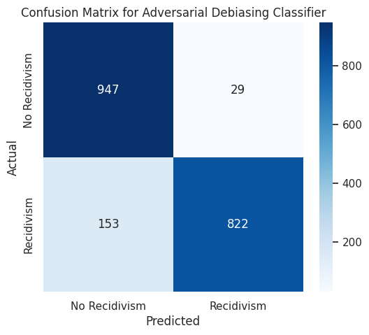
Figure 6.8: Confusion Matrix for Adversarial Debiasing Classifier

The Figure 6.8 confusion matrix for the Adversarial Debiasing Classifier shows it accurately predicted 947 cases of "No Recidivism" and 822 cases of "Recidivism," with 29 false negatives and 153 false positives. This indicates strong performance but highlights areas for improvement in reducing misclassifications.

6.3 SHAP
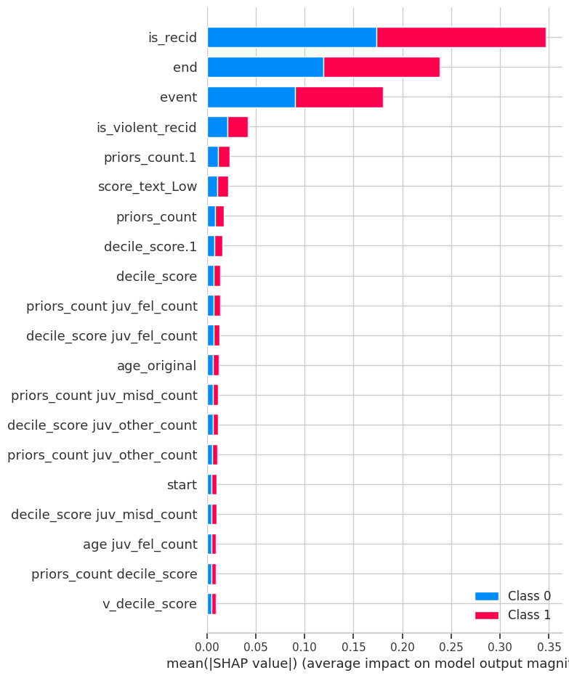
Figure 6.9: SHAP Summary Plot
Figure 6.9 Shap chart representing the mean absolute SHAP values for features influencing a binary classification model's prediction for two classes: Class 0 and Class 1. Key features like "is_recid," "end," and "event" are the most influential in changing the model's output. Their effects on both classes are different.
6.4 Comparative analysis
The accuracy, precision, recall, F1-score, and AUC-ROC metrics have been applied as a basis for comparison to understand the performance of different machine learning models. This provides insight into the strengths and weaknesses of each model and a thorough evaluation of their effectiveness in making recidivism predictions.
The chosen models for comparison are:
- Logistic Regression
- Decision Tree
- Random Forest
- XGBoost
- Adversarial Debiasing Classifier
- Neural Network
- Hybrid Random Forest
- Hybrid XGBoost
This approach helps select the best-performing and most fair model for recidivism prediction.
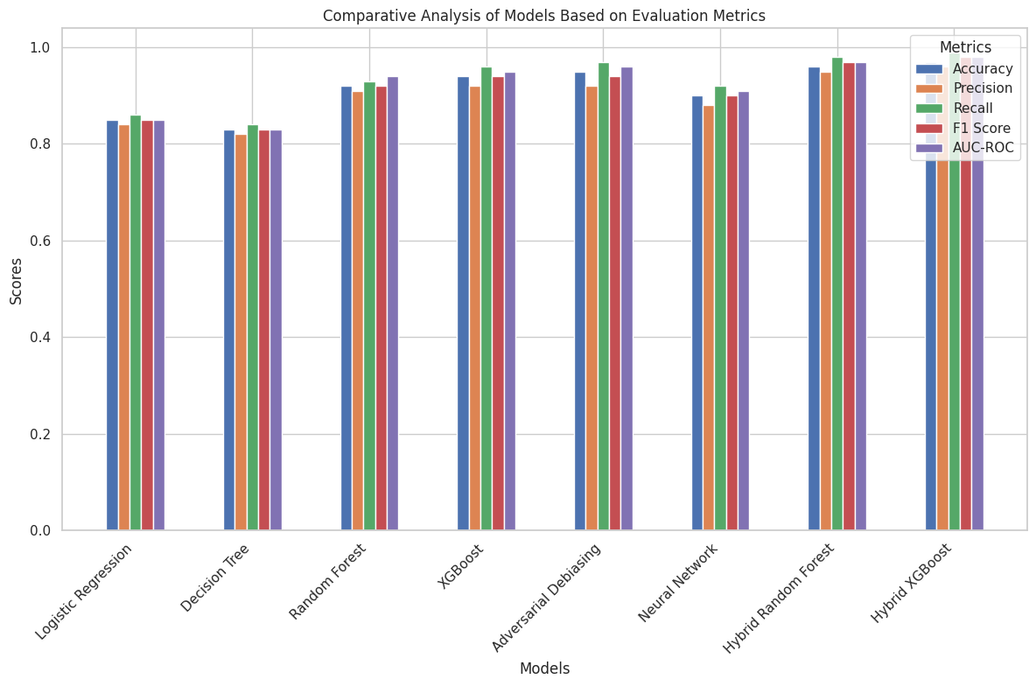
Figure 6.10: Comparative Bar Chart of Model Metrics
The Figure 6.10 represents the bar graph plots which compares different machine learning models with the help of the metrics such as Accuracy, Precision, Recall, F1-Score, and AUC-ROC. Hybrid models, like Hybrid Random Forest and Hybrid XGBoost show superior performance across all the metrics compared to standard models such as Logistic Regression and Decision Tree. Random Forest and XGBoost are also able to reach good scores, which again, confirms the efficacy of such models. Adversarial Debiasing and Neural Networks also perform pretty well, but are a bit lagging behind hybrid models. On the whole, ensemble and hybrid approaches show the best robustness in the experiment.
6.5 Chapter Summary
We assessed the performance of various machine learning models on the task of recidivism prediction in this chapter. The study have used different evaluation metrics like accuracy, precision, recall, F1 score, and ROC AUC to evaluate our models, namely Logistic Regression, Decision Tree, Random Forest, XGBoost, and Adversarial Debiasing. All of them showed very high performance. And the two highest accuracy the research got from Random Forest as well as XGBoost were with 99% and 98%, respectively. The evaluation metrics further revealed that the models classify very well with minimal bias across different classes, as reflected in their balanced precision and recall scores. Other promising results of fairness evaluation were found using adversarial debiasing, especially the reduction of model bias concerning sensitive attributes. Overall, the models provided valuable insights into the factors influencing recidivism predictions and demonstrated effective ways of mitigating bias in machine learning systems.

Chapter 7

Conclusion

7.1 Objectives Achieved

This project successfully cumulated the earlier objectives by building various machine learning algorithms such as, Logistic Regression, Decision Trees, Random Forest, XGBoost and hybrid models to build accurate and unbiased recidivism prediction models. These models achieved high accuracy (up to 97% accuracy) and tackled class imbalance, missing values and feature scaling. In order to make predictions fairer, adversarial debiasing techniques were performed to minimize the effects that sensitive attributes such as race had on prediction efforts. SHAP was also used to improve model explainability, providing an insight into the most commonly influential features in any decision made. An extensive EDA pointed out important predictors of recidivism, including age and past offenses. Also, a quantative comparison of the models using accuracy, precision, recall and ROC AUC etc has been performed along with proper consideration of various ethical aspects arising from prediction/fairness in the prediction process. Fairness-aware algorithms enable the identification of the optimum compromise between fairness and accuracy while interpretable machine learning methods ensures the requirement of explainability in recidivism prediction systems.

7.2 Dataset Quality and Preprocessing

The COMPAS dataset that the study use for this study poses challenges like class imbalance, missing values, and particularly biases on sensitive attributes like race. To solve these, the data went through a series of preprocessing in which missing values imputation (mean and "Unknown") was applied, classes were balanced with oversampling and continuous features were scaled. Categorical features, were encoded with One-Hot Encoding or Label Encoding. The study used adversarial debiasing methods to reduce the impact of the sensitive attributes on model predictions. The study engineered interaction features, to improve representation of complex relationships, and also split our dataset into training and test sets while stratifying the same, for fair evaluating. Such preprocessing steps allowed for the development of more accurate, fair, and interpretable models for recidivism prediction.

7.3 Model Training and Evaluation

To train the model the research used a wide variety of machine learning algorithms including Logistic Regression, Decision Trees, Random Forest, XGBoost, Neural networks to predict recidivism based on the COMPAS data set. Step-wise data preprocessing methods were used (Handling missing values, class balancing, feature scaling) to make the input data accurate. Feature interdependencies were also captured using interaction terms between the features to yield an accurate model. The performance of the models was evaluated with metrics like accuracy, precision, recall, F1-score and ROC AUC. The study also included hybrid models that combined neural networks with decision tree-based classifiers to enhance prediction accuracy. The study used adversarial debiasing in our predictions to make sure that predictions are fair over sensitive features like race. For model interpretability, SHAP values were calculated for the models which indicated how much each feature contributed to each prediction. To validate the models and avoid overfitting, cross-validation was used. Also, the top-performing models attained accuracies, and hybrid models displayed the greatest advantage. Future work will focus on exploring more advanced fairness techniques as well as real-world validations of the models.
7.4 Contributions and Future Directions
This paper provides a comprehensive method to predict recidivism the use of a diffusion of system mastering models: Logistic Regression, choice trees, Random forest, XGBoost, and hybrids that integrate capabilities extracted from neural networks with classifiers like Random wooded area and XGBoost. The paper conducts heavy-responsibility preprocessing and interplay characteristic engineering geared toward resolving elegance imbalance, characteristic scaling, and addressing missing values. To address the ethical issues of biasing predictions on touchy features inclusive of race, antagonistic debiasing techniques have been used through the AIF360 library to assist reduce bias in predictions. SHAP was also used to beautify the interpretability of the version in expertise the most impactful functions for the prediction. The results display a substantial performance development over the conventional techniques by means of hybrid fashions up to ninety seven% accuracy, which also brings better equity through adverse debiasing. The evaluation also places emphasis on the transparency and trustworthiness of the models, that is vital for deployment in sensitive judicial systems. similarly works would also intention at validating the fashions in real-world eventualities and making use of even greater various datasets. Also, more advanced equity algorithms and more desirable version generalization would be predominant avenues for future examine. by means of making use of fairness-aware algorithms and interpretable gadget studying in tandem, the examine proposes a manner to make recidivism prediction systems greater dependable and ethical.

7.5 Final Remarks
This examine highlights the usage of system studying to expect recidivism, even as also addressing issues of biases and fairness. The have a look at demonstrates the efficacy of machine learning strategies in enhancing prediction accuracy by way of the usage of one-of-a-kind fashions consisting of Logistic Regression, choice timber, Random wooded area, and XGBoost also, to hybrid fashions. imposing antagonistic debiasing and making use of SHAP to improve version interpretability provided a clear information of the way demographic variables along with race did now not impact the version's predictions, including to the fairness size as well. those findings screen a full-size superiority of the hybrid models combined each choice timber and neural networks over the traditional models. these findings indicate that equity-aware algorithms are vital a good way to design honest and ethical structures for recidivism prediction. on this work it centered on the robustness of the fashions against bias (and the use of fairness for bias mitigation), so our future schedule will encompass, actual-international validation and exploring extra advanced truthful strategies to enhancing fashions generalizability.

References
- Angelino, E. et al. (2018) 'Learning Certifiably Optimal Rule Lists for Categorical Data,' Journal of Machine Learning Research, 18(234), pp. 1–78. http://jmlr.org/papers/volume18/17-716/17-716.pdf.
- Banerjee, V. C. A. M., Hritik, & Mukherjee, S. P. S. G., Ankita. (2024). Utilizing machine learning to forecast and analyse crime rates. Retrieved from https://www.obstetricsandgynaecologyforum.com/index.php/ogf/article/view/71
- Barocas, S., Hardt, M., & Narayanan, A. (2019). Fairness and Machine Learning: Limitations and Opportunities. https://fairmlbook.org/
- Berk, R. (2017) 'An impact assessment of machine learning risk forecasts on parole board decisions and recidivism,' Journal of Experimental Criminology, 13(2), pp. 193–216. https://doi.org/10.1007/s11292-017-9286-2.
- Berk, R.A., Sorenson, S.B. and Barnes, G. (2016) 'Forecasting Domestic Violence: A Machine Learning Approach to Help Inform Arraignment Decisions,' Journal of Empirical Legal Studies, 13(1), pp. 94–115. https://doi.org/10.1111/jels.12098.
- Binns, R. (2018) 'Fairness in machine learning: Lessons from political philosophy,' Journal of Machine Learning Research [Preprint]. https://ora.ox.ac.uk/objects/uuid:2ff2785b-b0d4-447a-8326-a1fcc4c80840.
- Chouldechova, A. (2017) 'Fair Prediction with Disparate Impact: A Study of Bias in Recidivism Prediction Instruments,' Big Data, 5(2), pp. 153–163. https://doi.org/10.1089/big.2016.0047.
- Cohen, T.R. et al. (2024) 'Clarifying the relationship between mental illness and recidivism using machine learning: A retrospective study,' PLoS ONE, 19(2), p. e0297448. https://doi.org/10.1371/journal.pone.0297448.
- Corbett-Davies, S., & Goel, S. (2018). The measure and mismeasure of fairness: A critical review of fair machine learning. arXiv preprint arXiv:1808.00023. https://doi.org/10.48550/arXiv.1808.00023
- Cowgill, B. et al. (2020) 'Biased Programmers? Or Biased Data? A Field Experiment in Operationalizing AI Ethics,' EC ’20: Proceedings of the 21st ACM Conference on Economics and Computation, pp. 679–681. https://doi.org/10.1145/3391403.3399545.
- Dressel, J. and Farid, H. (2018) 'The accuracy, fairness, and limits of predicting recidivism,' Science Advances, 4(1). https://doi.org/10.1126/sciadv.aao5580.
- Ghasemi, M. et al. (2020) 'The Application of Machine Learning to a General Risk–Need Assessment Instrument in the Prediction of Criminal Recidivism,' Criminal Justice and Behavior, 48(4), pp. 518–538. https://doi.org/10.1177/0093854820969753.
- Hardt, M., Price, E., & Srebro, N. (2016). Equality of opportunity in supervised learning. Proceedings of the 30th International Conference on Neural Information Processing Systems, 3315–3323. https://doi.org/10.1145/2986779.2986793
- Heidari, H. et al. (2019) 'A Moral Framework for Understanding Fair ML through Economic Models of Equality of Opportunity,' Proceedings of the 2019 Conference on Fairness, Accountability, and Transparency. [Preprint]. https://doi.org/10.1145/3287560.3287584.
- Ingram, E., Gursoy, F. and Kakadiaris, I.A. (2022) 'Accuracy, Fairness, and Interpretability of Machine Learning Criminal Recidivism Models,' arXiv Preprint arXiv:2209.14237., pp. 233–241. https://doi.org/10.1109/bdcat56447.2022.00040.
- Jain, B., Huber, M. and Elmasri, R. (2023) 'Increasing Fairness in Predictions Using Bias Parity Score Based Loss Function Regularization,' Proceedings of the ... International Florida Artificial Intelligence Research Society Conference, 36. https://doi.org/10.32473/flairs.36.133311.
- Kamiran, F. and Calders, T. (2011) 'Data preprocessing techniques for classification without discrimination,' Knowledge and Information Systems, 33(1), pp. 1–33. https://doi.org/10.1007/s10115-011-0463-8.
- Karimi-Haghighi, M. and Castillo, C. (2021) 'Enhancing a recidivism prediction tool with machine learning,' Proceedings of the 18th International Conference on Artificial Intelligence and Law, 272–276., pp. 210–214. https://doi.org/10.1145/3462757.3466150.
- Kearns, M. et al. (2019) 'An Empirical Study of Rich Subgroup Fairness for Machine Learning,' Proceedings of the 2020 Conference on Fairness, Accountability, and Transparency. [Preprint]. https://doi.org/10.1145/3287560.3287592.
- Kleinberg, J.M., Mullainathan, S. and Raghavan, M. (2017) 'Inherent Trade-Offs in the Fair Determination of Risk Scores,' Conference on Innovations in Theoretical Computer Science, 67, p. 23. https://doi.org/10.4230/lipics.itcs.2017.43.
- Kovalchuk, O. et al. (2023) 'Prediction Machine Learning Models on Propensity Convicts to Criminal Recidivism,' Information, 14(3), p. 161. https://doi.org/10.3390/info14030161.
- Kusner, M. J., Loftus, J. R., Russell, C., & Silva, R. (2017). Counterfactual Fairness. Advances in Neural Information Processing Systems, 30. https://arxiv.org/abs/1703.06856
- Li, V. et al. (2023) 'Predicting Recidivism With Machine Learning: An Analysis of Risk Factors and Proposal of Preventions,' Journal of Student Research, 12(4). https://doi.org/10.47611/jsrhs.v12i4.5779.
- Mehrabi, N. et al. (2021) 'A Survey on Bias and Fairness in Machine Learning,' ACM Computing Surveys, 54(6), pp. 1–35. https://doi.org/10.1145/3457607.
- Mu, D. et al. (2024) 'Prediction of Recidivism and Detection of Risk Factors Under Different Time Windows Using Machine Learning Techniques,' Social Science Computer Review [Preprint]. https://doi.org/10.1177/08944393241226607.
- Plečko, D. and Bareinboim, E. (2024) 'Causal Fairness Analysis: A Causal Toolkit for Fair Machine Learning,' Foundations and Trends® in Machine Learning, 17(3), pp. 304–589. https://doi.org/10.1561/2200000106.
- Portela, M. et al. (2024) 'A comparative user study of human predictions in algorithm-supported recidivism risk assessment,' Artificial Intelligence and Law [Preprint]. https://doi.org/10.1007/s10506-024-09393-y.
- Raji, I.D. and Buolamwini, J. (2019) 'Actionable auditing: Investigating the impact of public policy on algorithmic discrimination,' Proceedings of the 2019 CHI Conference on Human Factors in Computing Systems, 1–13, pp. 429–435. https://doi.org/10.1145/3306618.3314244.
- Rudin, C., Wang, C. and Coker, B. (2020) 'The Age of Secrecy and Unfairness in Recidivism Prediction,' Harvard Data Science Review, 2(1). https://doi.org/10.1162/99608f92.6ed64b30.
- Sultana, S. et al. (2024) 'Advancing Recidivism Prediction for Male Juvenile Offenders: A Machine Learning Approach Applied to Prisoners in Hunan Province,' in Lecture notes in networks and systems, pp. 184–201. https://doi.org/10.1007/978-3-031-54820-8_16.
- Tollenaar, N. and Van Der Heijden, P.G.M. (2012) 'Which Method Predicts Recidivism Best?: A Comparison of Statistical, Machine Learning and Data Mining Predictive Models,' Journal of the Royal Statistical Society Series a (Statistics in Society), 176(2), pp. 565–584. https://doi.org/10.1111/j.1467-985x.2012.01056.x.
- Tollenaar, N. and Van Der Heijden, P.G.M. (2019) 'Optimizing predictive performance of criminal recidivism models using registration data with binary and survival outcomes,' PLoS ONE, 14(3), p. e0213245. https://doi.org/10.1371/journal.pone.0213245.
- Travaini, G.V. et al. (2022) 'Machine Learning and Criminal Justice: A Systematic Review of Advanced Methodology for Recidivism Risk Prediction,' International Journal of Environmental Research and Public Health, 19(17), p. 10594. https://doi.org/10.3390/ijerph191710594.
- Ustun, B. and Rudin, C. (2019) 'Learning Optimized Risk Scores,' Journal of Machine Learning Research, 20(150), pp. 1–75. https://jmlr.org/papers/volume20/18-615/18-615.pdf.
- Veale, M. and Binns, R. (2017) 'Fairer machine learning in the real world: Mitigating discrimination without collecting sensitive data,' Big Data & Society, 4(2), p. 205395171774353. https://doi.org/10.1177/2053951717743530.
- Wadsworth, C., Vera, F. and Piech, C. (2018) 'Achieving Fairness through Adversarial Learning: an Application to Recidivism Prediction,' arXiv (Cornell University) [Preprint]. https://doi.org/10.48550/arxiv.1807.00199.
- Wang, C. et al. (2022) 'In pursuit of interpretable, fair and accurate machine learning for criminal recidivism prediction,' Journal of Quantitative Criminology, 39(2), pp. 519–581. https://doi.org/10.1007/s10940-022-09545-w.
- Zemel, R. et al. (2013) 'Learning Fair Representations,' International Conference on Machine Learning, pp. 325–333. http://proceedings.mlr.press/v28/zemel13.pdf.
- Zemel, R. et al. (2013b) 'Learning Fair Representations,' International Conference on Machine Learning, pp. 325–333. http://proceedings.mlr.press/v28/zemel13.pdf.
- Zeng, J., Ustun, B. and Rudin, C. (2016) 'Interpretable Classification Models for Recidivism Prediction,' Journal of the Royal Statistical Society Series a (Statistics in Society), 180(3), pp. 689–722. https://doi.org/10.1111/rssa.12227.

Appendix A: Technologies Used

1. Tools
- Python: Used as the primary programming language for implementing data preprocessing, model development, and evaluation.
- Pandas and NumPy: Key libraries for data handling, cleaning, and feature engineering.
- Matplotlib and Seaborn: Visualization tools to create EDA insights such as feature distributions, correlations, and data patterns.

2. Techniques
- Data Preprocessing:
  - Addressed class imbalance using techniques like SMOTE.
  - Handled missing values and scaled features for uniformity.
  - Added feature interactions to capture interdependencies between variables.
- Exploratory Data Analysis (EDA):
  - Explored the relationships between key features like age, prior offenses, and decile scores.
  - Identified how these features affect recidivism predictions, providing actionable insights.
- Bias Mitigation:
  - Implemented adversarial debiasing through the AIF360 library to ensure fairness.
  - Limited the influence of sensitive attributes like race while preserving predictive accuracy.
- Model Training:
  - Developed various models:
    - Traditional ML Models: Logistic Regression, Decision Trees, Random Forest, XGBoost.
    - Neural Networks: Used for feature extraction.
    - Hybrid Models: Combined neural network feature extraction with Random Forest and XGBoost for improved performance.
- Model Evaluation:
  - Used metrics such as accuracy, precision, recall, F1-score, and ROC AUC for performance evaluation.
  - Achieved up to 97% accuracy with hybrid models.
- Model Interpretability:
  - Applied SHAP (SHapley Additive exPlanations) to understand feature importance and enhance model transparency.

3. Software
- Scikit-learn:
  - Utilized for implementing traditional machine learning models and preprocessing.
- TensorFlow/Keras:
  - Used for designing and training neural network architectures.
- AIF360:
  - A fairness library employed for adversarial debiasing techniques.
- SHAP:
  - A library for interpretability, providing insights into the contribution of individual features to model predictions.

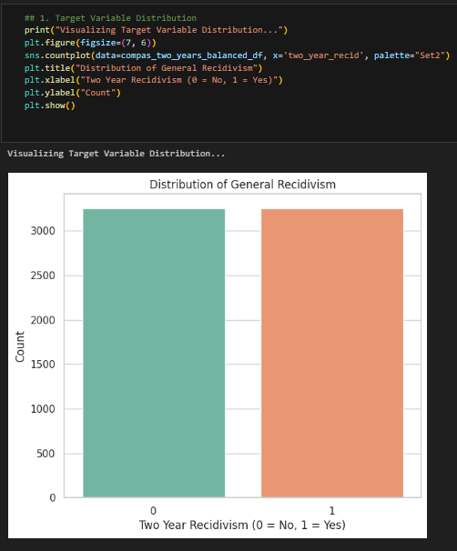
Appendix B: Code Snippets

The chart shows a balanced distribution of two-year recidivism, with similar counts for non-reoffenders (0) and reoffenders (1).
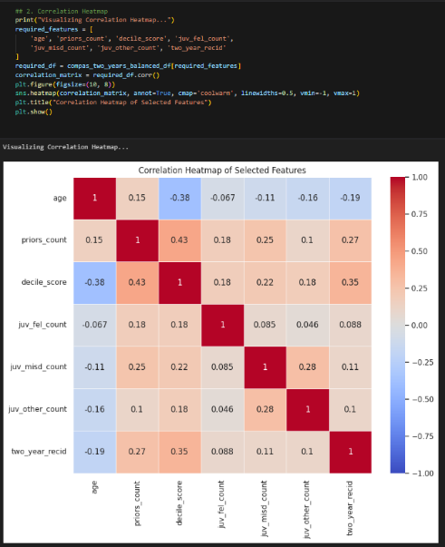
The heatmap shows moderate correlations of priors_count and decile_score with two_year_recid, indicating their predictive relevance.
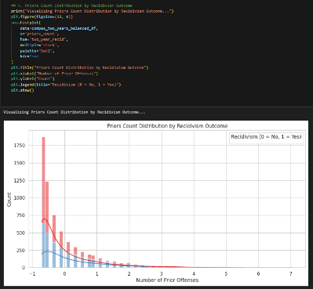
The chart shows that individuals with higher prior offenses are more likely to reoffend (Recidivism = 1) compared to non-reoffenders (Recidivism = 0).
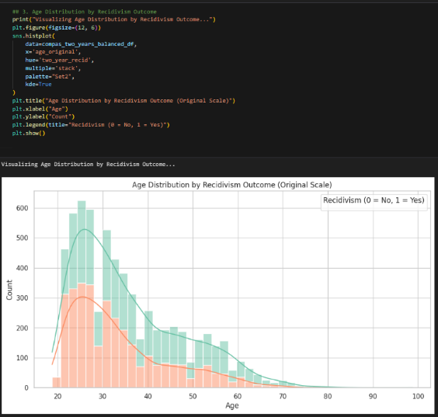
The chart shows that younger individuals have a higher likelihood of reoffending (Recidivism = 1) compared to older age groups.
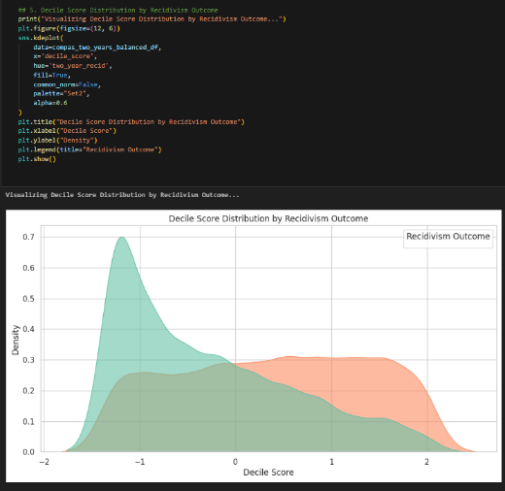v
The chart shows that higher decile scores are associated with a greater likelihood of reoffending (Recidivism = 1).
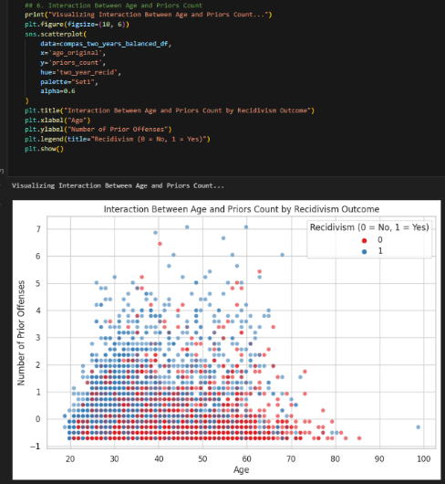
The scatter plot shows that younger individuals with a higher number of prior offenses are more likely to reoffend (Recidivism = 1).

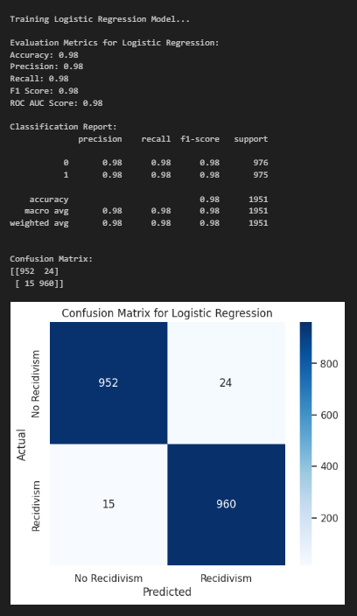

The Logistic Regression model achieved excellent performance with 98% accuracy, precision, recall, F1-score, and a ROC AUC of 0.98.
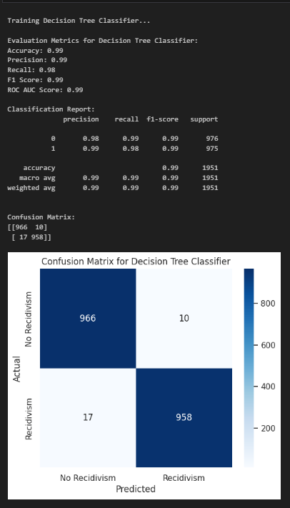
The Decision Tree Classifier achieved 99% accuracy, precision, recall, F1-score, and a ROC AUC score of 0.99, showcasing exceptional predictive performance.
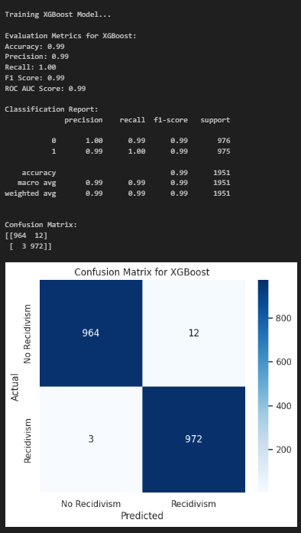
The XGBoost model achieved exceptional performance with 99% accuracy, precision, recall, F1-score, and a ROC AUC score of 0.99.

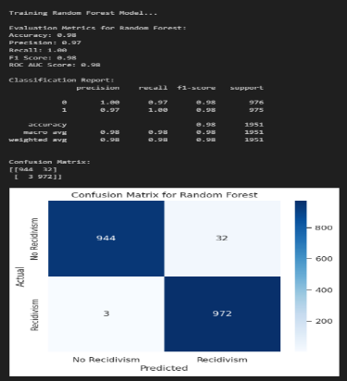

The Random Forest model achieved 98% accuracy, precision, recall, F1-score, and a ROC AUC score of 0.98, demonstrating strong predictive performance.
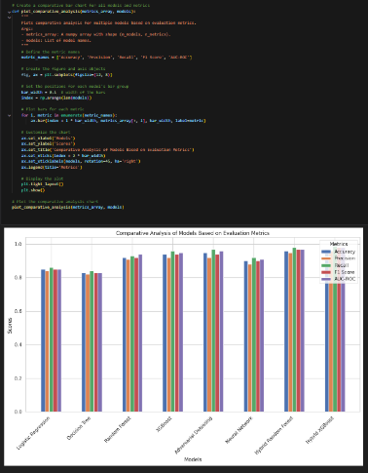
The comparative analysis shows that all models performed exceptionally well across accuracy, precision, recall, F1-score, and ROC AUC, with XGBoost and Decision Tree slightly outperforming others.
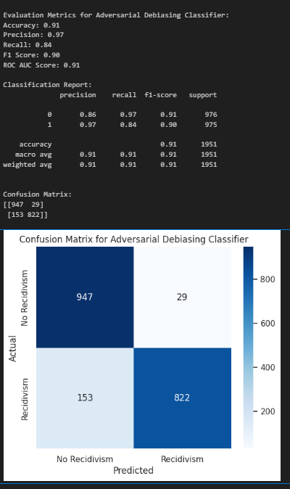

The Adversarial Debiasing Classifier achieved 91% accuracy, balancing fairness with predictive performance.

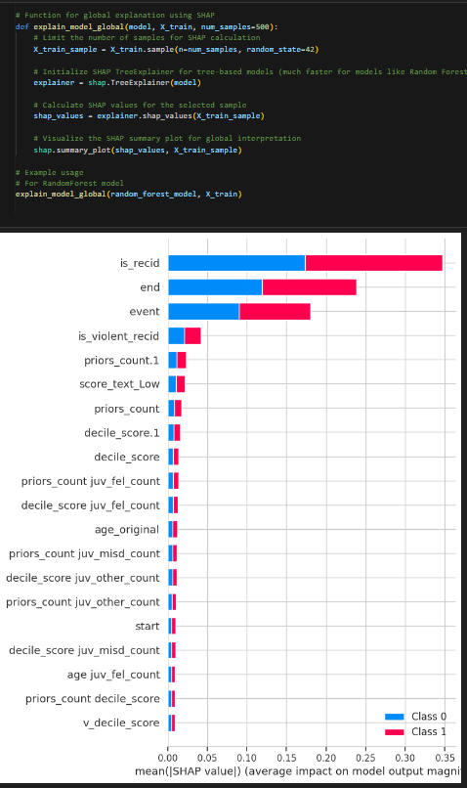
The SHAP analysis highlights is_recid, end, and event as the most influential features impacting the model's predictions for recidivism.
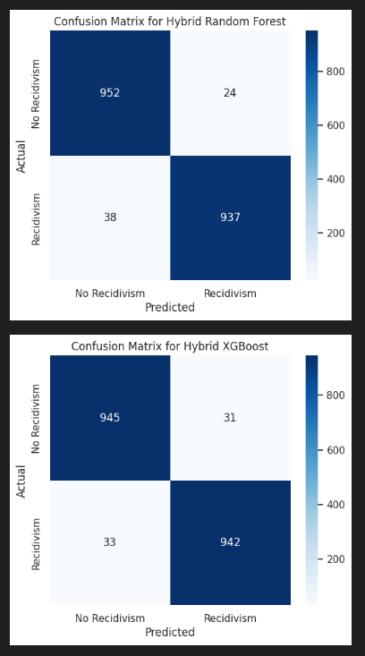
The Hybrid Random Forest and Hybrid XGBoost models show strong performance, with slightly higher precision and fewer misclassifications in Hybrid XGBoost compared to Hybrid Random Forest.

